

Lab Manual

DS-303
Data Mining

Submitted by

Muhammad Zain Sattar 2023-BS-AI-052(A)

Submitted to

Mr. Muhammad Arham

Department of Computer Science

TABLE OF CONTENTS

Lab 01 | KNIME Introduction…………………………………………………………………………4
Lab 02 Customer Churn Prediction…………………………………………………………………10
Lab 03 | Data Cleaning…………………………………………………………………15
Lab 04 Data Preprocessing…………………………………………………………………19
Lab 05 | Market Basket Analysis…………………………………………………………………26
Lab 06 Apriori Algorithm — Product Combination Analysis………………………………………30
Lab 07 | FP-Growth — Efficient Frequent Pattern Mining…………………………………………………………………33
Lab 08 Python Basics — Reusable Data Processing Module…………………………………………………………………36
Lab 09 | Decision Tree…………………………………………………………………40
Lab 10 Naïve Bayes & KNN…………………………………………………………………43
Lab 11 | SVM — Support Vector Machine…………………………………………………………………47
Lab 12 Clustering — K-Means…………………………………………………………………51
Lab 13 | Outlier Detection…………………………………………………………………55
Lab 14 Scraping & Sentiment Analysis…………………………………………………………………58
Lab 15 | Final Capstone Project…………………………………………………………………60

________________________________________________________
Lab 1: KNIME Introduction
________________________________________________________

Real-World Scenario: A retail company stores large volumes of transaction records across product categories. Without organized analysis, raw data cannot support strategic decision-making. Business managers require clear analytical outputs to measure overall revenue, estimate average customer purchase value, identify top-earning categories, and determine which products yield the highest profit contribution.

Dataset Description
The dataset applied in this exercise is a Retail Sales CSV file containing detailed transaction records. Each row represents one completed sale with fields including Transaction ID, Product Title, Product Category, Quantity Sold, Unit Price, Purchase Date, and Sales Amount.

Software Tool: KNIME Analytics Platform
KNIME is a visual analytics platform that allows users to create data workflows by connecting functional nodes. Every node handles a specific task — importing files, cleaning data, applying formulas, generating summaries, or performing aggregations. Combined, these nodes form a complete data analysis pipeline.

Learning Outcomes

1  . | Load a CSV sales dataset into KNIME using the CSV Reader node.
2  .  3  .  4  .  5  . | Inspect and adjust column data types for accurate processing.
 | Generate descriptive statistics to understand dataset properties.
 | Create a new Revenue column using the Math Formula node.
 | Analyse four major retail KPIs using GroupBy and Sorter nodes.

Procedure

Download the Dataset
Obtain the Retail Sales dataset in CSV format from the provided source and save it locally for analysis.
STEP 1

Create a New Workflow
STEP 2
Launch KNIME Analytics Platform and create a new workflow named Retail Sales Analysis to organise the analytical process.

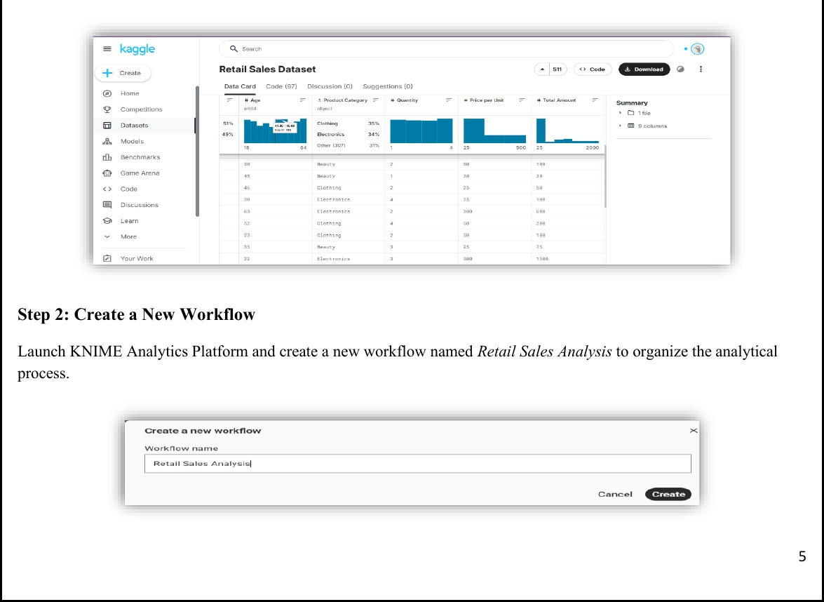

Figure 1.1 — Kaggle dataset preview & KNIME workflow creation dialog

Import the Dataset
STEP 3
Use the CSV Reader node to load the Retail Sales dataset into the workflow environment and verify successful execution.

Verify the Data Types
STEP 4
Inspect all columns to ensure numeric fields (Quantity, Price, Revenue) are typed as Integer or Double, and categorical fields (Category, Product Name) are set as String.

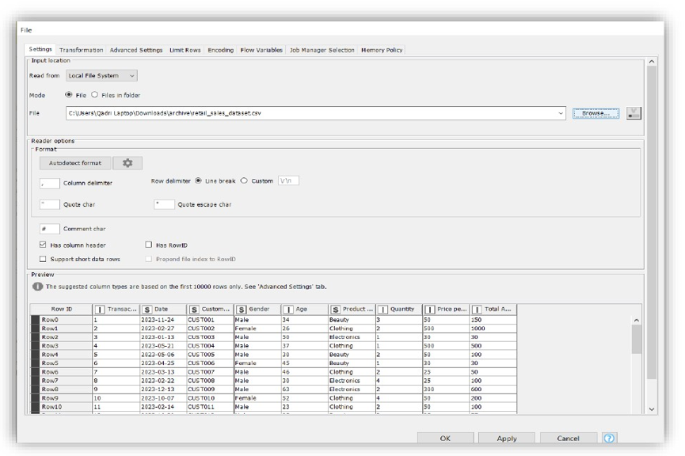

Generate Summary Statistics
STEP 5
Apply the Statistics node to compute descriptive measures — mean, minimum, maximum, sum, and standard deviation — for all numeric attributes.

Calculate Revenue Column
STEP 6
Use the Math Formula node to create a new Revenue column: Revenue = Quantity × Price. This derived column is used for all KPI calculations.

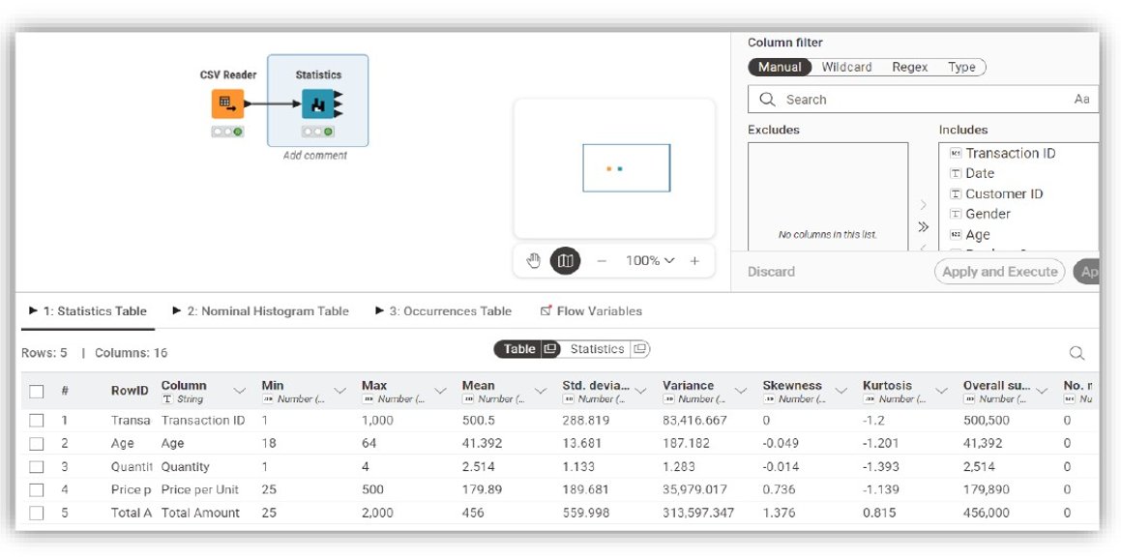

Total Revenue (KPI 1)
STEP 7
Add a GroupBy node with no grouping column and aggregate Revenue using Sum to compute overall sales revenue.

View Total Revenue Result
STEP 8
Execute the node and observe the single output value representing total revenue across all transactions.

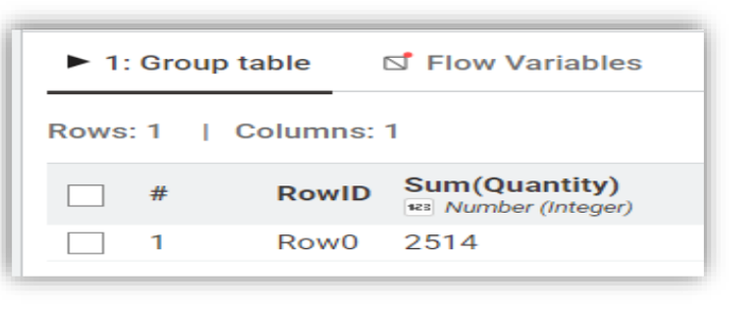

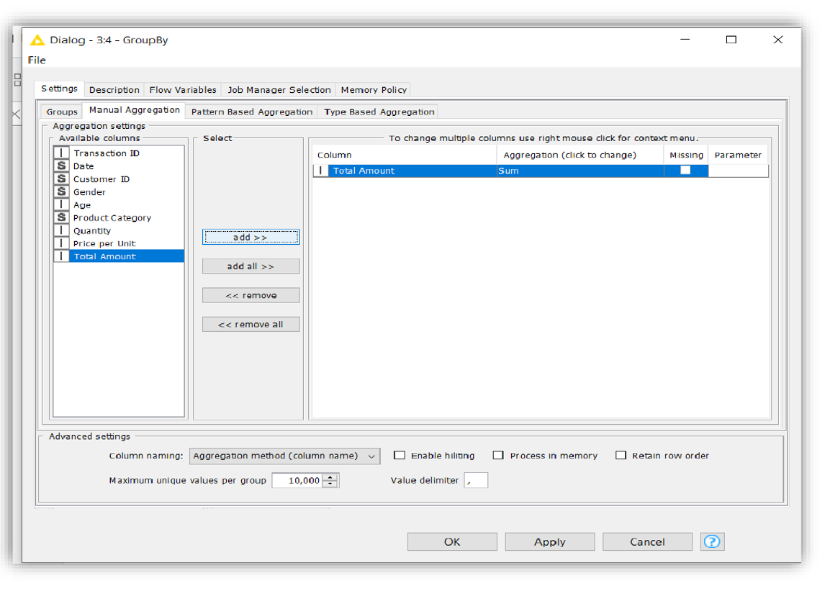

Revenue per Transaction
STEP 9
Add a GroupBy node grouped by Transaction ID and aggregate Revenue using Sum for each individual order.

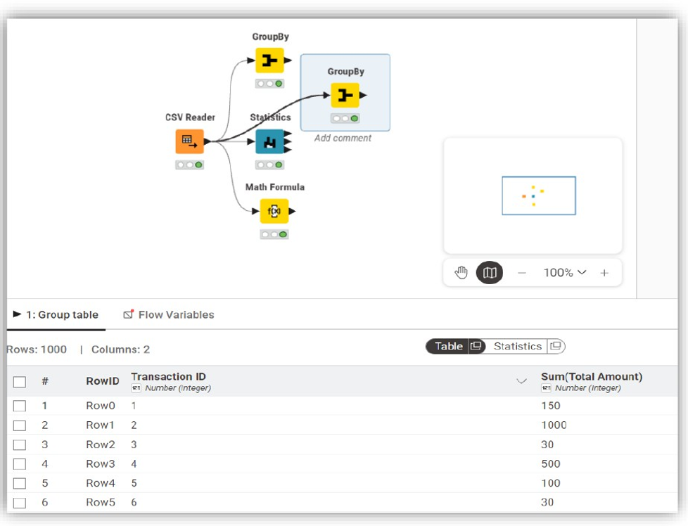

Average Order Value (KPI 2)
STEP 10
Connect a second GroupBy node with no grouping column and calculate the Mean of aggregated revenue.
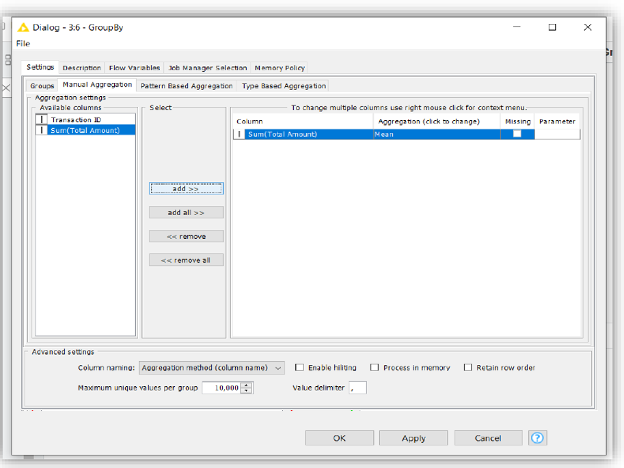

View Average Order Value
STEP 11
Execute and review the output showing average revenue per transaction.

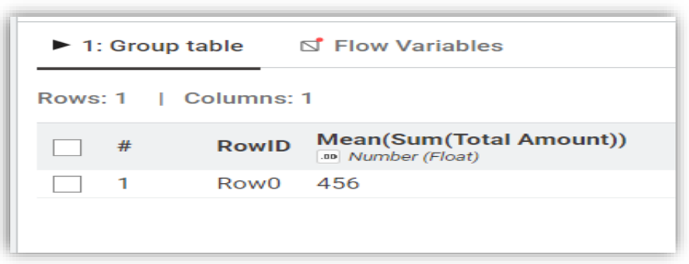

Revenue by Category (KPI 3)
STEP 12
Add a GroupBy node grouped by Product Category and aggregate Revenue using Sum for each category.

Sort by Highest Revenue Category
STEP 13
Connect a Sorter node configured for descending order to rank categories from highest to lowest.

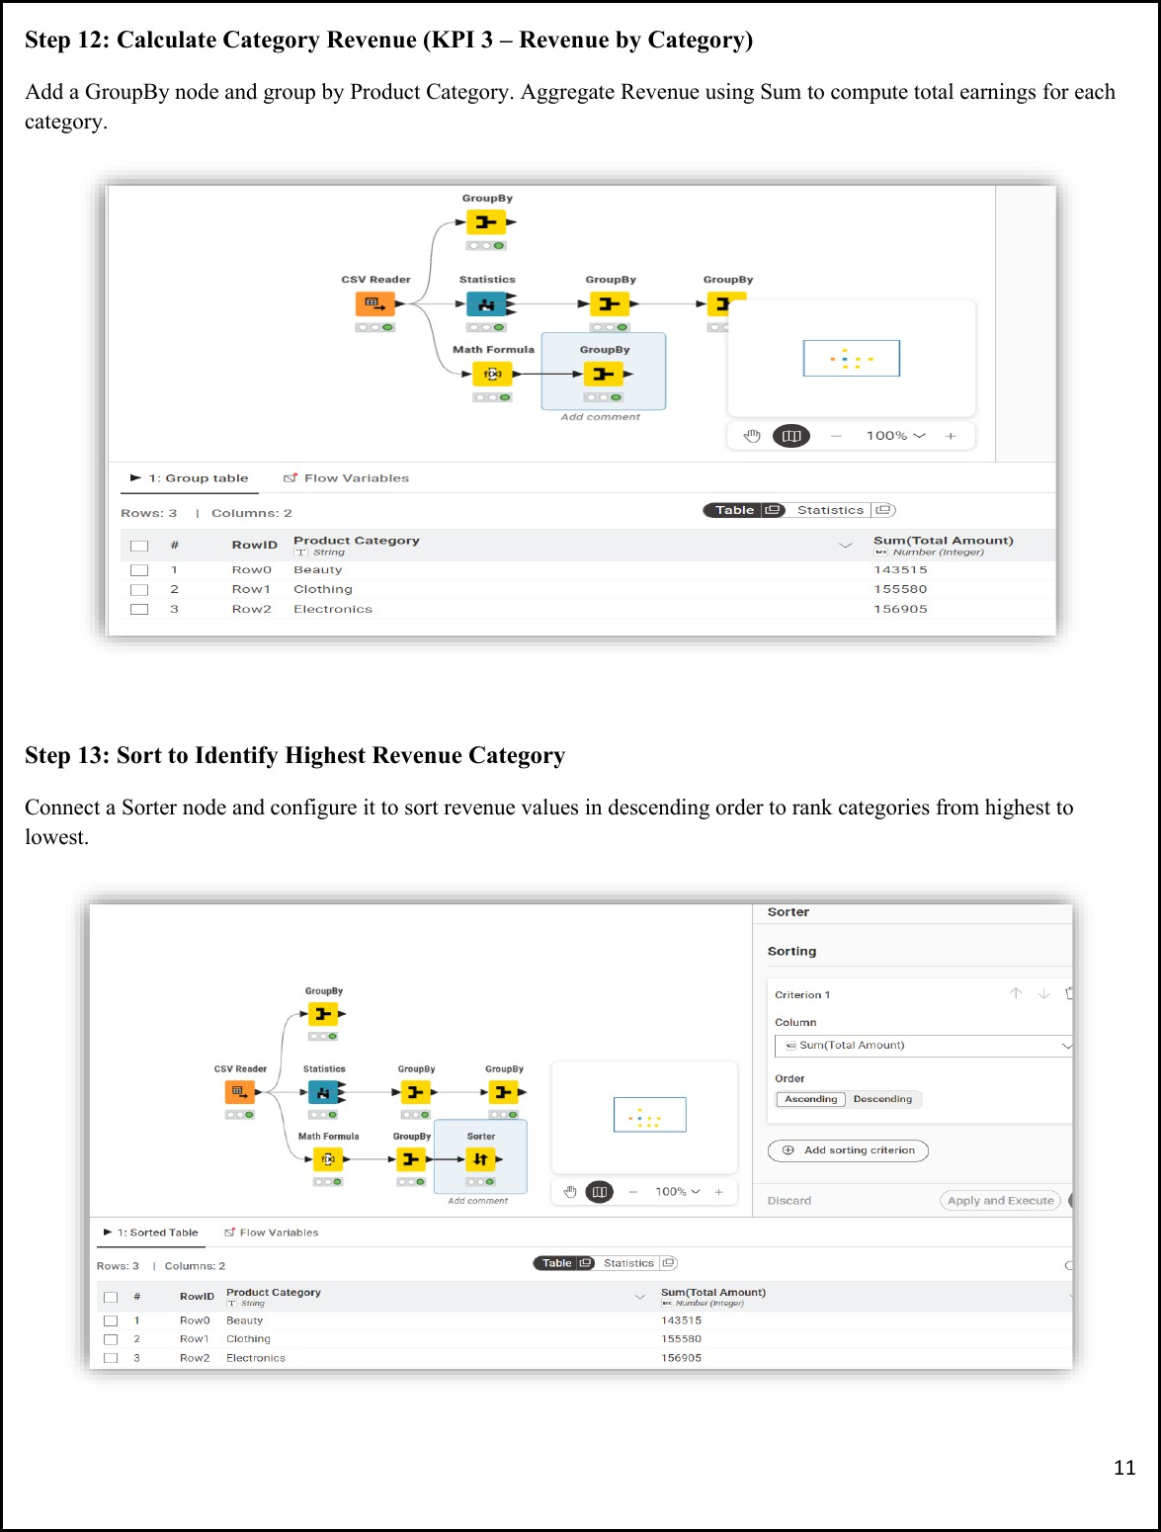

________________________________________________________
Lab 2: Customer Churn Prediction
________________________________________________________

Real-World Scenario: An e-commerce business aims to identify customers likely to discontinue its services. Undetected churn leads to revenue loss and missed retention opportunities. This lab applies the CRISP-DM methodology with Orange Data Mining to build a predictive churn model.

Dataset: Churn_Modelling.csv
10,000 customer records with 14 attributes. The target column is Exited (1 = Churned, 0 = Retained). Input features include Credit Score, Geography, Gender, Age, Tenure, Account Balance, Number of Products, Credit Card Ownership, Active Membership Status, and Estimated Salary. Columns RowNumber, CustomerId, and Surname are excluded during preprocessing.

Software: Orange Data Mining
Orange is a free, open-source visual data mining tool for building machine learning workflows by connecting widgets on a canvas — supporting data import, preprocessing, classification, evaluation, and visualisation without coding.

Learning Objectives

1  . | Import and inspect a CSV dataset using File and Data Table widgets.
2  .  3  .  4  .  5  .  6  .  7  . | Remove unnecessary columns and assign the target variable using Select Columns.
 | Normalise numerical data and encode categorical features using Preprocess.
 | Train Logistic Regression and Random Forest classification models.
 | Compare model performance using Test and Score with 10-fold cross-validation.
 | Analyse results using Confusion Matrix and ROC Analysis.
 | Compute business KPIs: Churn Rate and Retention Rate.

Procedure

Load the Dataset
Use the File widget to load Churn_Modelling.csv and connect it to a Data Table widget to verify all 10,000 rows and 14 columns are loaded correctly.
STEP 1

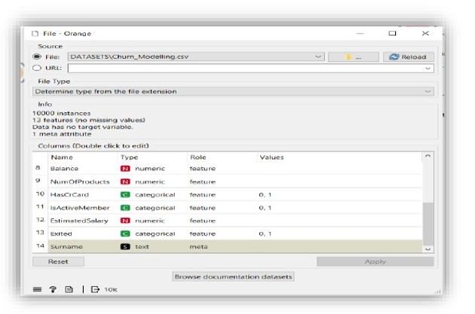

Figure 2.1 — Orange File widget loading Churn_Modelling.csv

Select Columns
STEP 2
Connect to a Select Columns widget. Move RowNumber, CustomerId, and Surname to the Ignore list. Set Exited as the Target class and retain all remaining features.

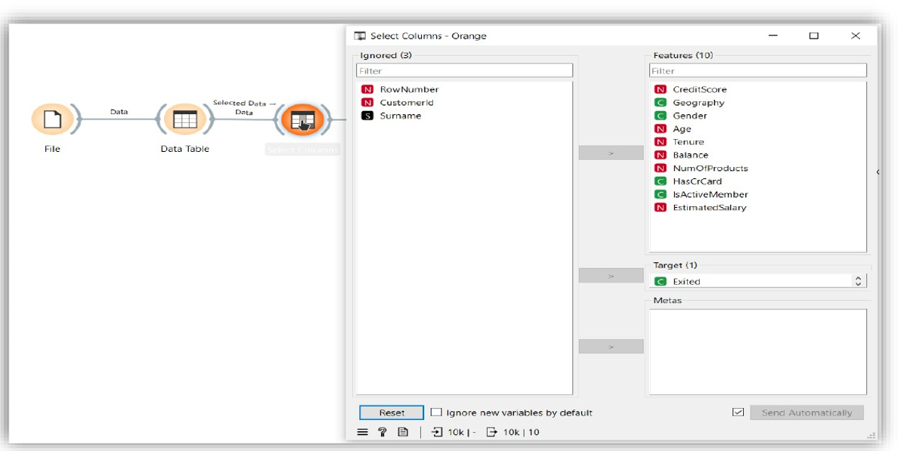

Preprocess
STEP 3
Connect to a Preprocess widget and enable Min-Max normalisation to scale all numeric features between 0 and 1.

Add Models
STEP 4
Connect the Preprocess widget to both a Logistic Regression widget and a Random Forest widget using the Preprocessor output port.

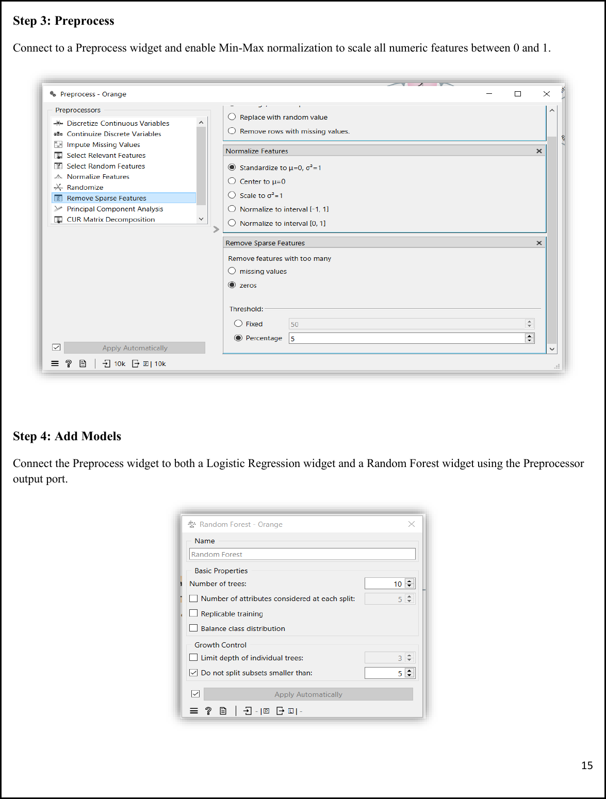

Test and Score
STEP 5
Connect both learners and the preprocessed data to the Test and Score widget. Set evaluation to Cross Validation with 10 folds and enable Stratified splitting.

Evaluate
STEP 6
Connect Test and Score to a ROC Analysis widget and Confusion Matrix widget to visualise model performance.

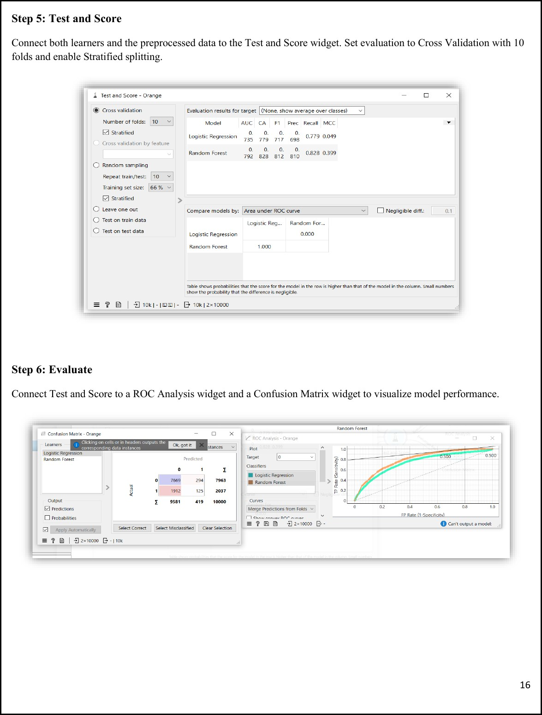

Results & KPIs

KPI | Result
Churn Rate | 20.37%
Retention Rate | 79.63%
Logistic Regression AUC | 0.735
Random Forest AUC | 0.792
Random Forest Accuracy | 82.8%
Random Forest F1 Score | 0.812
Key Insight: Random Forest outperformed Logistic Regression across all metrics. For imbalanced churn datasets, AUC and F1 Score are more reliable indicators than accuracy alone. The model can be deployed to score customers and trigger early retention actions for high-risk segments.

________________________________________________________
Lab 3: Data Cleaning
________________________________________________________

Real-World Scenario: Raw healthcare data often includes errors such as missing information, duplicate records, and unrealistic billing values. These issues reduce the accuracy of medical analysis. An organised data cleaning process is necessary to convert raw patient records into a reliable,
analysis-ready form.

Dataset: Healthcare Records
55,500 rows and 15 columns. Attributes include Patient Name, Age, Gender, Blood Type, Medical Condition, Billing Amount, Admission Type, and Medication. Cleaning focus areas: text standardisation, missing value handling, numeric outlier removal, and duplicate elimination.

Software: Python — Pandas & NumPy

Learning Objectives

1  . | Detect and handle missing values in healthcare records.
2  .  3  .  4  .  5  . | Remove duplicate rows to improve data consistency.
 | Standardise text values and filter invalid numerical entries.
 | Prepare a clean dataset suitable for healthcare analytics.
 | Calculate KPIs: % Missing Values Reduced, Duplicate Removal %, Data Quality Score.

Procedure

Environment Setup & Data Loading
Import Pandas and NumPy, then load the healthcare dataset and perform an initial inspection of its structure.
STEP 1

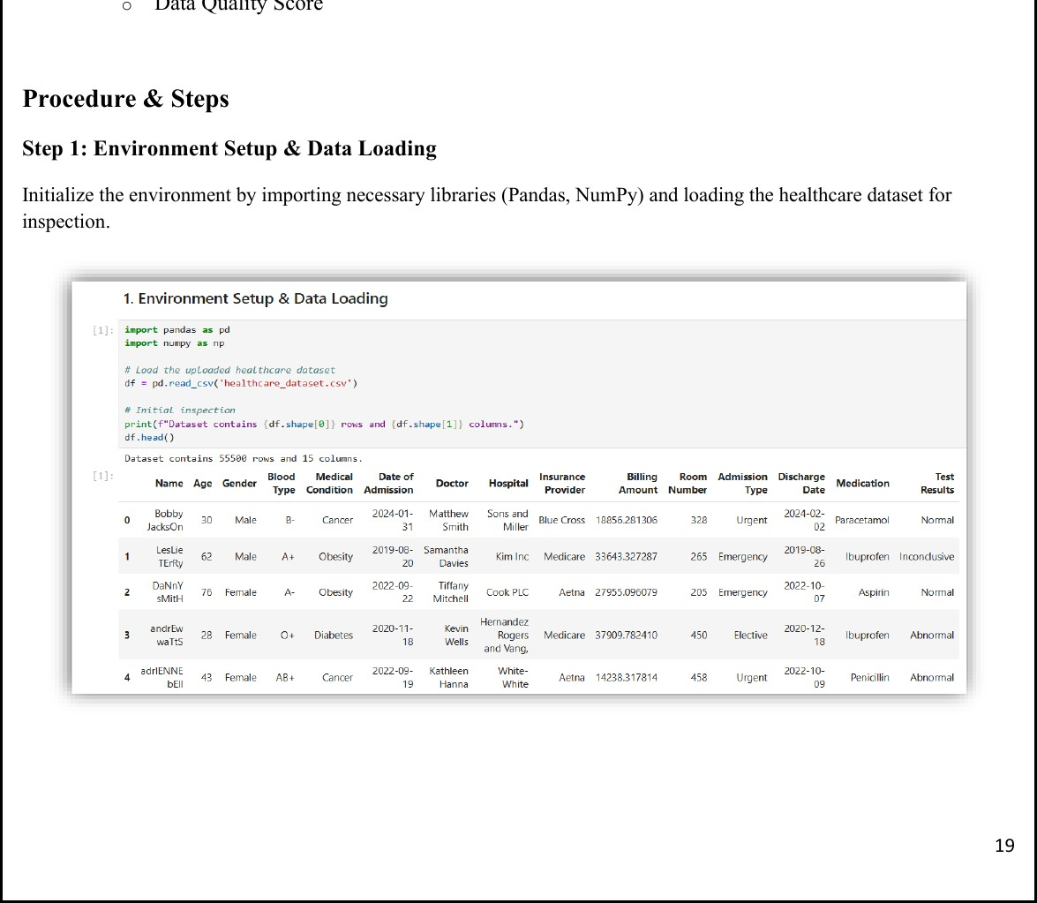

Figure 3.1 — Environment setup and dataset loaded (55,500 rows × 15 columns)

Initial Data Inspection (Quality Audit)
STEP 2
Check the dataset dimensions and identify initial issues: missing values across columns, duplicate row count, and noise records such as negative billing amounts.

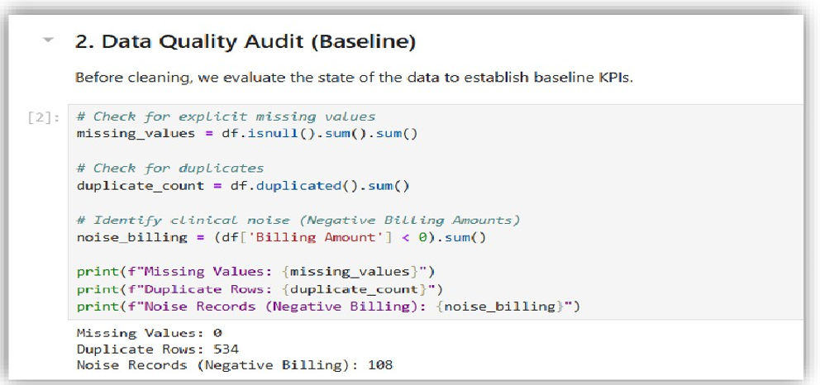

Duplicate Record Removal
STEP 3
Scan the dataset for identical patient entries and remove redundant rows to ensure uniqueness. Result: 534 duplicates removed (0.96% reduction).

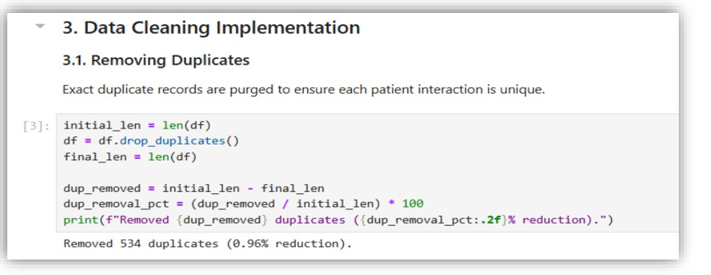

Clinical Noise Filtering & Standardising
STEP 4
Standardise text casing (Title Case for names) and remove illogical numeric outliers such as billing amounts ≤ 0.

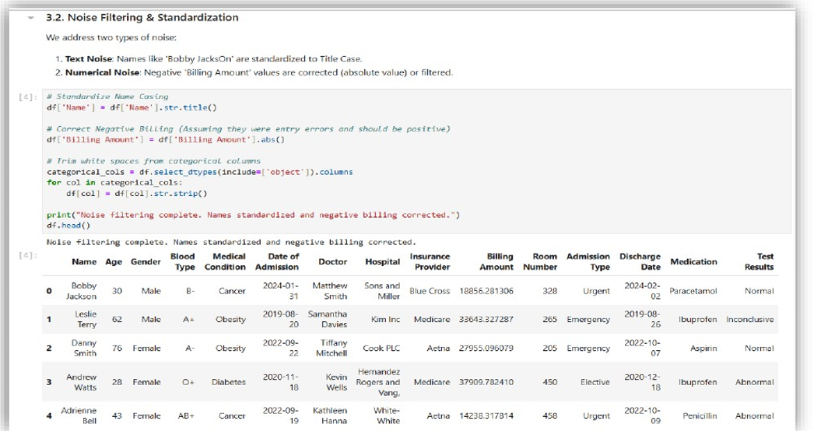

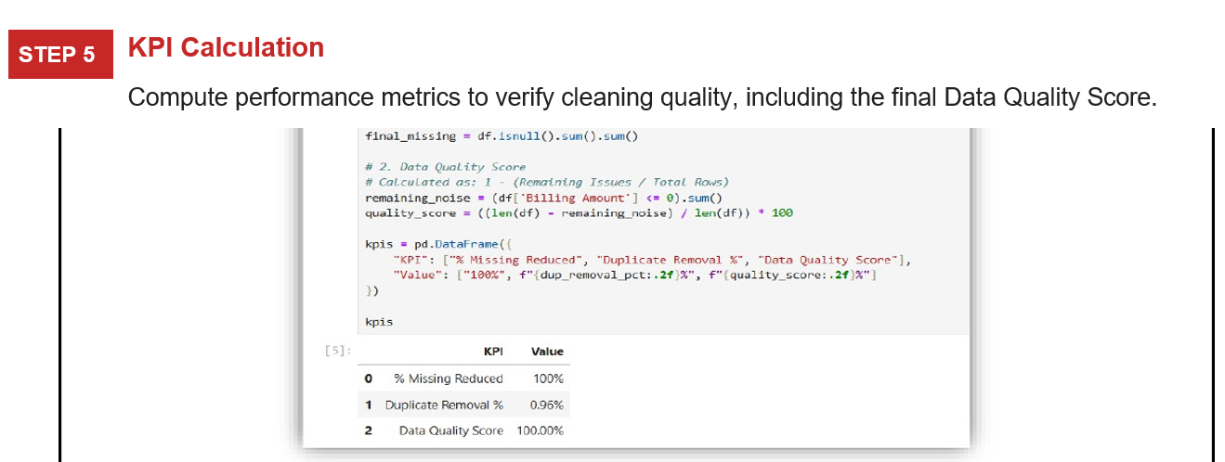

Export Cleaned Data
STEP 6
Save the final processed dataset as cleaned_healthcare_data.csv for future analysis.

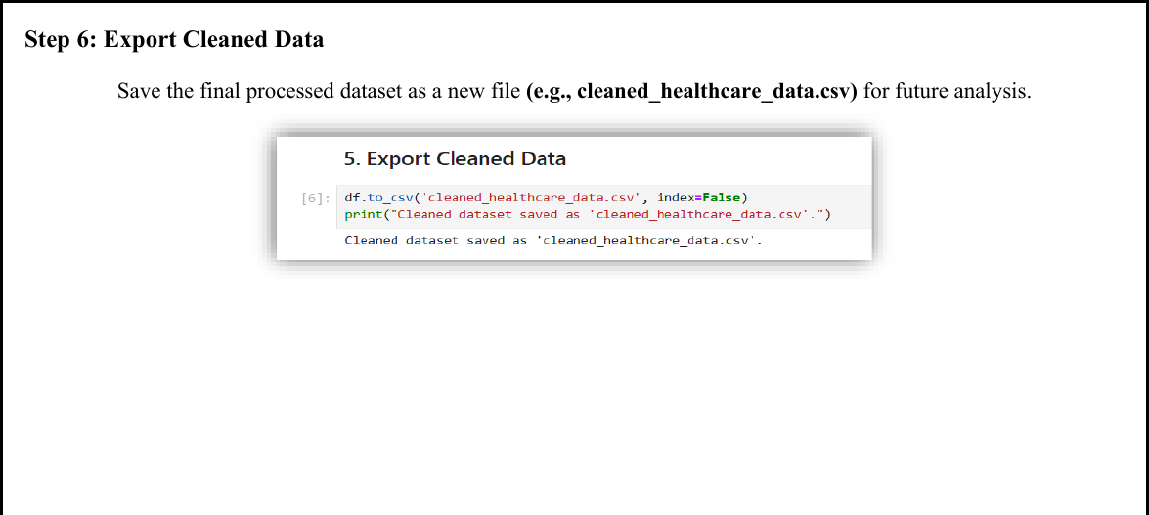
Figure 3.6 — Export confirmation

________________________________________________________
Lab 4: Data Preprocessing
________________________________________________________

Real-World Scenario: A banking institution must evaluate loan applicant risk before granting approvals. Raw loan datasets contain missing values, unequal data scales, and continuous variables requiring transformation before reliable predictive models can be built.

Dataset: Loan Applications — 20,000 Records
Key attributes: Age, Annual Income, Monthly Income, Debt-to-Income Ratio, Credit Score, Loan Amount, Interest Rate, Loan Term, and Installment Amount. After handling missing values, 8,231 clean records remained for processing.

Software: RapidMiner Studio

Learning Objectives

1  . | Import a CSV dataset using the Retrieve operator.
2  .  3  .  4  .  5  .  6  .  7  . | Handle incomplete records using Replace Missing Values.
 | Normalise numerical features through Z-Score Normalisation.
 | Apply Z-Score Peak Transformation to reduce outlier effects.
 | Convert continuous variables into categories using Discretisation.
 | Generate descriptive summaries using the Statistics operator.
 | Measure preprocessing success via Variance Reduction and Distribution Improvement KPIs.

Procedure

Load the Dataset
Use the Retrieve operator to load loan_dataset_20000.csv into the workflow and connect it to begin preprocessing.
STEP 1

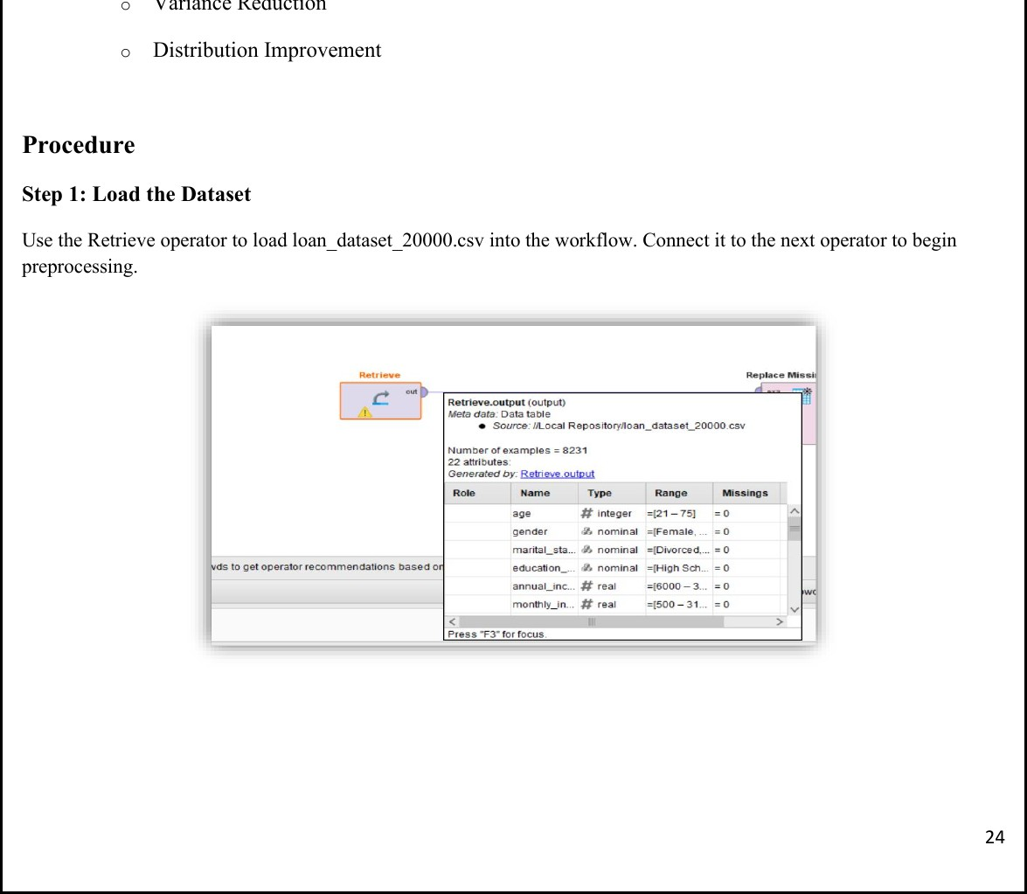

Replace Missing Values
STEP 2
Connect to a Replace Missing Values operator, removing or imputing missing entries — reducing the dataset from 20,000 to 8,231 valid records.

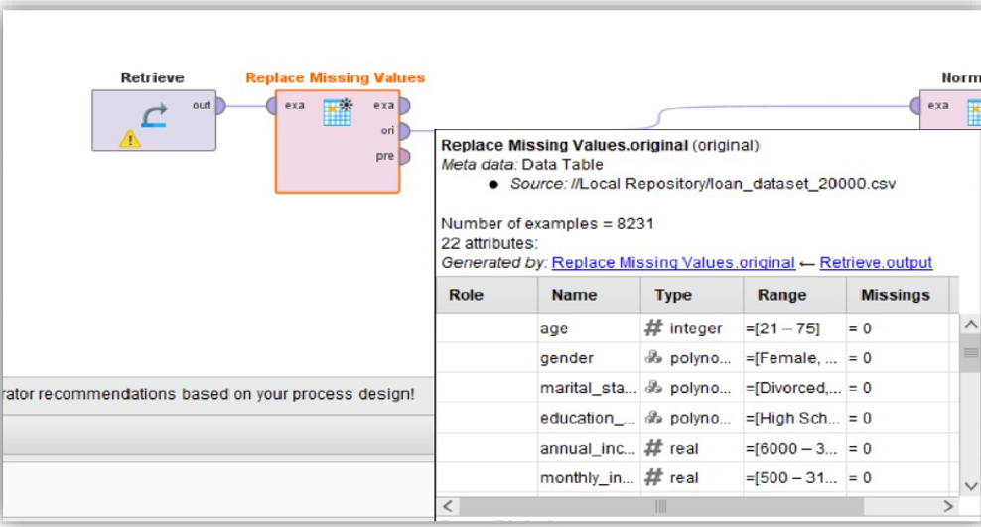

Normalise
STEP 3

Connect to a Normalise operator and apply Z-Score normalisation to scale all numeric
features to mean=0 and standard deviation=1

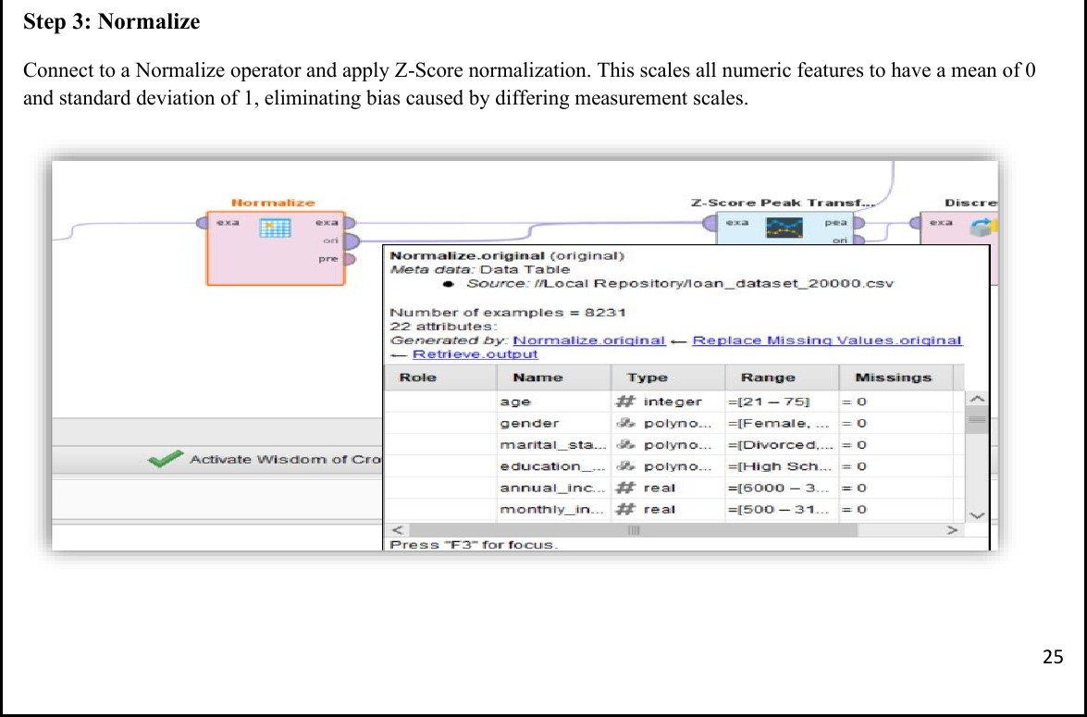

Figure 4.3 — Z-Score Normalisation configured

Z-Score Peak Transformation
STEP 4
Identify and handle extreme outlier values that remain after normalisation, producing a cleaner distribution.

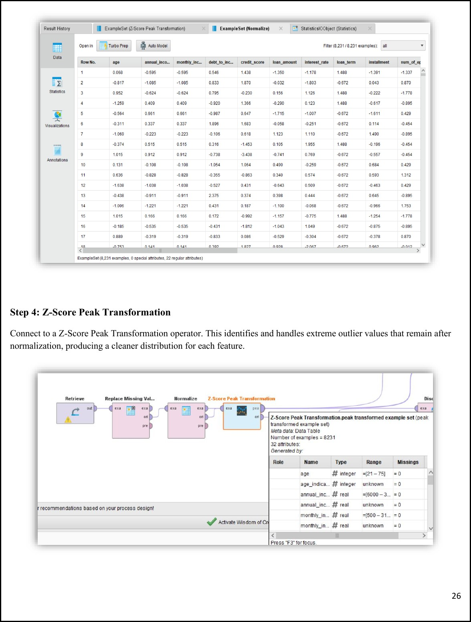

Figure 4.4 — Z-Score Peak Transformation output showing normalised feature values

Discretise
STEP 5
Connect to a Discretise operator to convert continuous numeric columns into categorical bins for rule-based or classification models.
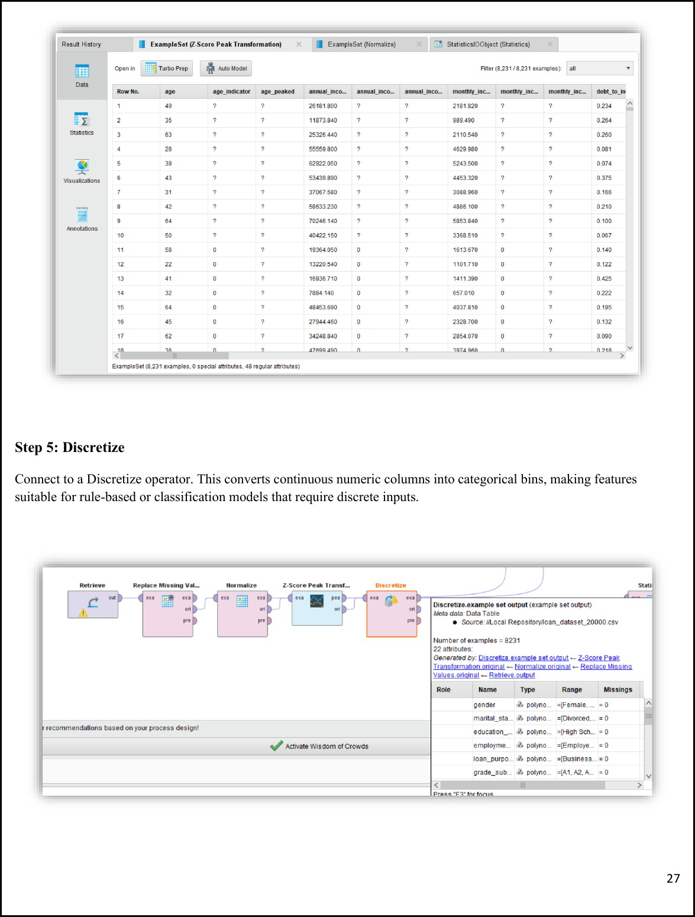

Figure 4.5 — Discretise operator output with binned attributes

Generate Statistics
STEP 6
Connect all outputs to a Statistics operator for a summary report: minimum, maximum, average, and standard deviation.
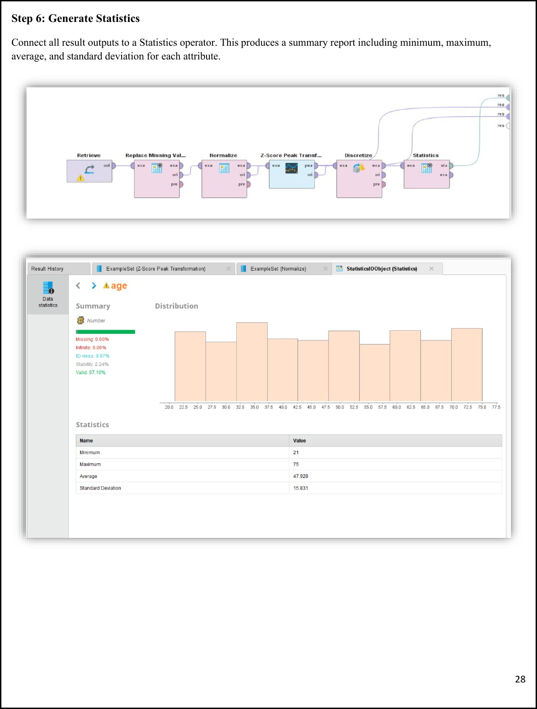

Figure 4.6 — Complete preprocessing pipeline and Statistics summary for Age

Results & KPIs

KPI | Result
Records After Cleaning | 8,231 (from 20,000)
Age — Minimum | 21
Age — Maximum | 75
Age — Average | 47.928
Age — Standard Deviation | 15.831
Missing Values After Processing | 0.00%
Valid Data Rate | 97.10%

________________________________________________________
Lab 5: Market Basket Analysis
________________________________________________________

Real-World Scenario: Supermarkets process vast numbers of daily purchases. Without pattern analysis, businesses miss opportunities for strategic product placement, promotional bundles, and cross-selling.
Discovering frequently co-purchased products helps retailers increase average basket value.

Dataset: Groceries Dataset
Member-based shopping transaction records. Attributes: Member_number, Date, ItemDescription. Each row represents one purchased item; records are grouped by member and date to form 14,963 unique transactions.

Software: Python — Pandas, itertools, collections

Learning Objectives

1  . | Identify frequent itemsets appearing regularly in customer baskets.
2  .  3  .  4  . | Perform association rule mining using Support, Confidence, and Lift.
 | Compare manual metric calculations with program-generated results.
 | Evaluate cross-selling potential using High Lift (>1) and strong Confidence values.

Procedure

Data Preparation & Transaction Grouping
Group raw CSV data by Member_number and Date to form unique transactions — converting individual item records into complete shopping baskets.
STEP 1

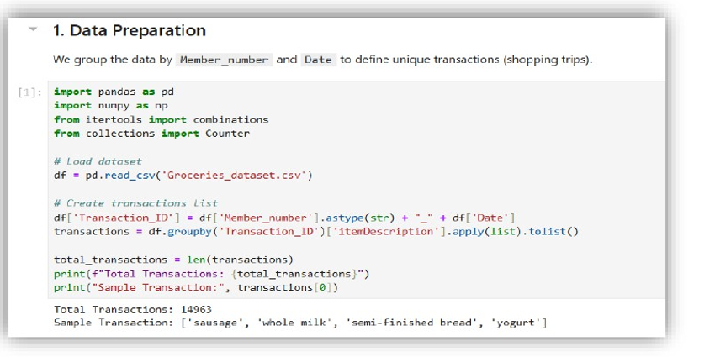

Manual Calculation of Support, Confidence & Lift
STEP 2
Manually calculate the three metrics for a specific item pair to validate the logic.

For the pair whole milk → yogurt: Support(A,B) 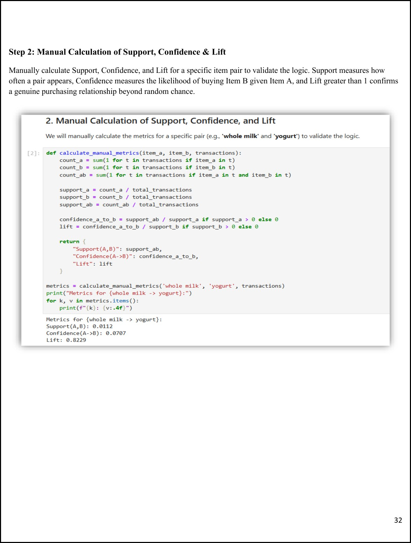=0.0112, Confidence(A→B)=0.0707, Lift=0.8229

Frequent Itemsets & Rule Generation
STEP 3
Compute metrics for every possible item pair across all transactions. Both directions (A→B and B→A) are evaluated and ranked by Lift.
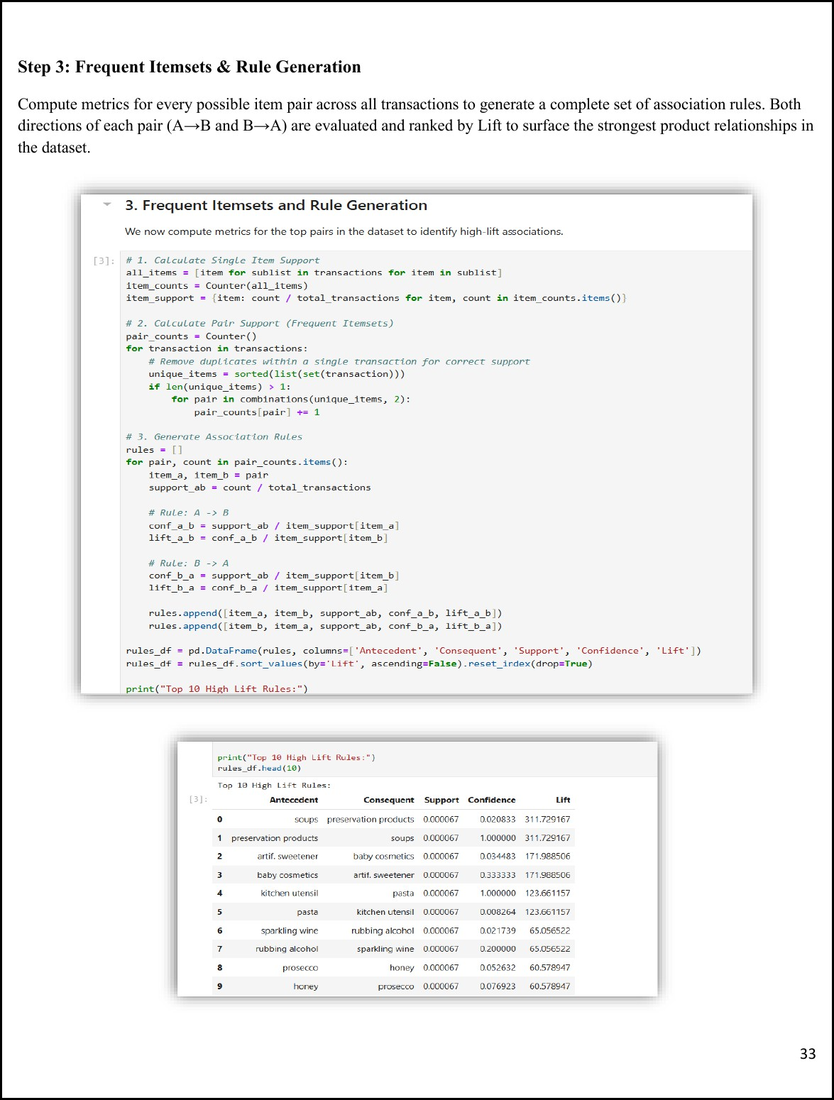

Filtering Significant Rules
STEP 4
Filter to isolate rules with Lift > 1 and Confidence > 0.05 — the most actionable cross-selling opportunities.

Strategic Conclusion
STEP 5
Identify high-lift item pairs as prime candidates for shelf co-location, promotional bundling, and targeted cross-selling.

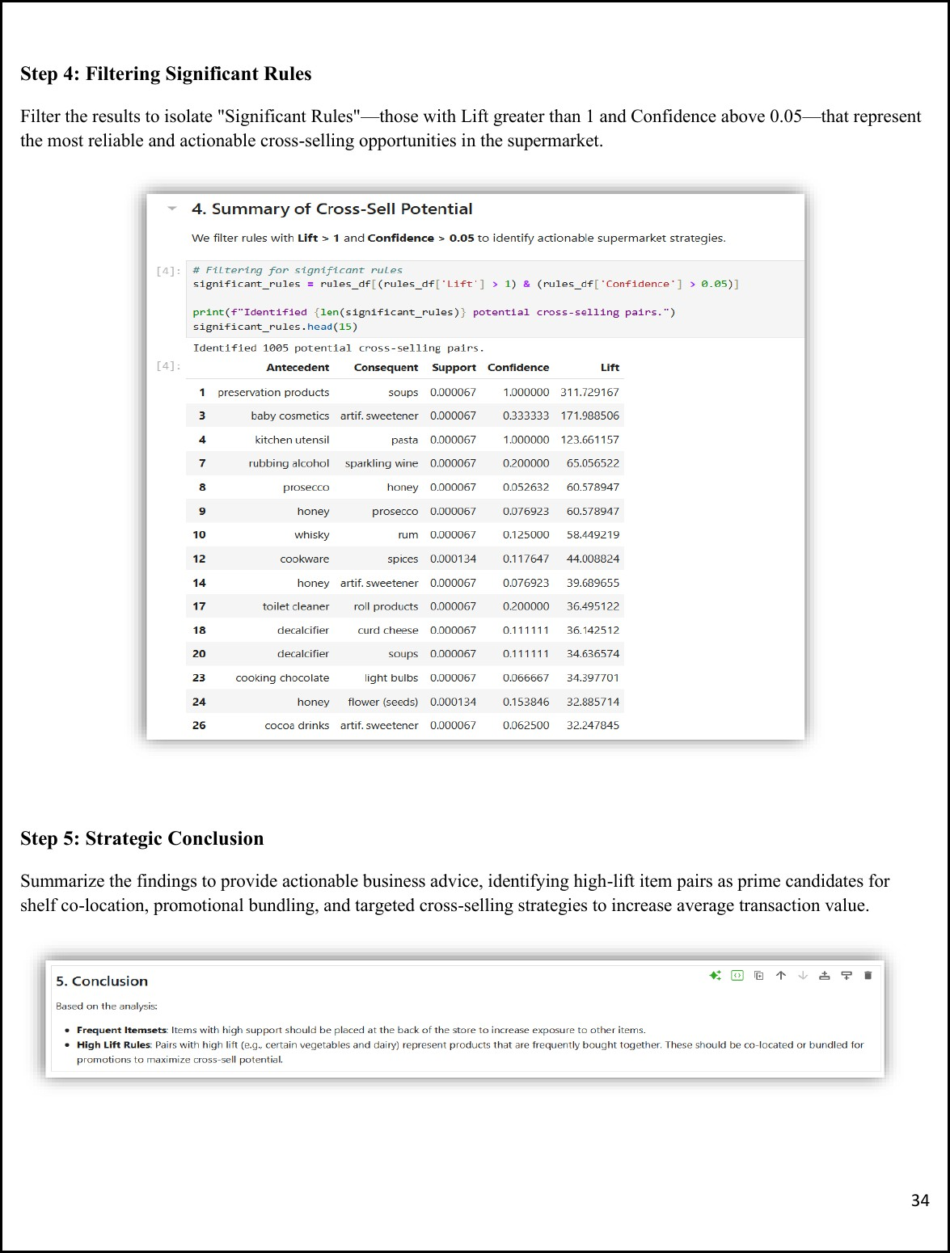

________________________________________________________
Lab 6: Apriori Algorithm
________________________________________________________

Real-World Scenario: Retail businesses process high volumes of daily purchases. Hidden buying relationships between product categories often go unnoticed without proper analytical methods. The Apriori algorithm identifies frequently co-purchased categories, enabling targeted promotions, product bundles, and improved customer retention.

Dataset: Retail Transaction Dataset
Attributes: CustomerID, ProductCategory, Quantity. Records grouped by CustomerID form unique customer baskets. The transaction matrix covers 95,215 customers across 4 product categories: Books, Clothing, Electronics, and Home Decor.

Software: Python — mlxtend (apriori, association_rules)

Learning Objectives

1  . | Convert raw purchase data into a binary customer-item basket matrix.
2  .  3  .  4  . | Discover frequent itemsets appearing together in customer purchase histories.
 | Generate association rules and evaluate using Support, Confidence, and Lift.
 | Analyse how changes in minimum support threshold affect the number of rules generated.

Procedure

Environment Setup & Data Preparation
Install mlxtend and load the dataset. Group by CustomerID and ProductCategory, then encode quantities into binary values (1=purchased, 0=not) to build the transaction matrix.
STEP 1
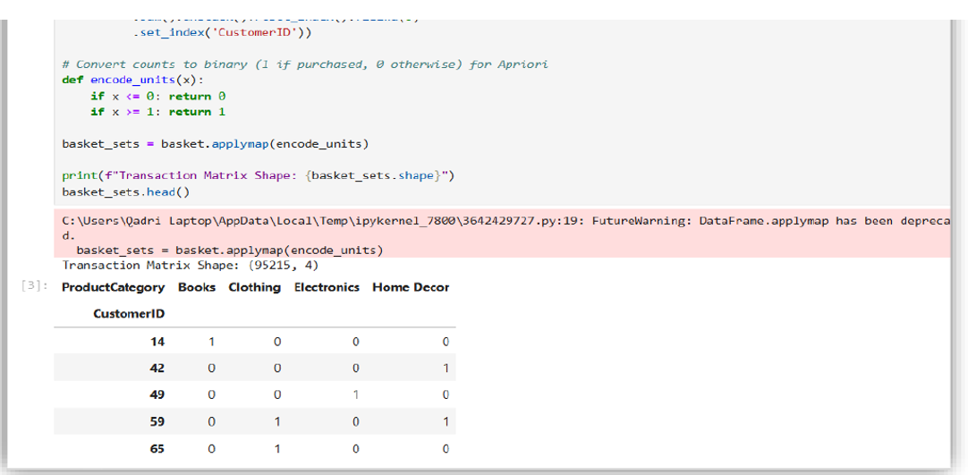

Frequent Itemset Generation
STEP 2
Apply the Apriori algorithm with minimum support of 0.01 to identify categories appearing in at least 1% of customer baskets.

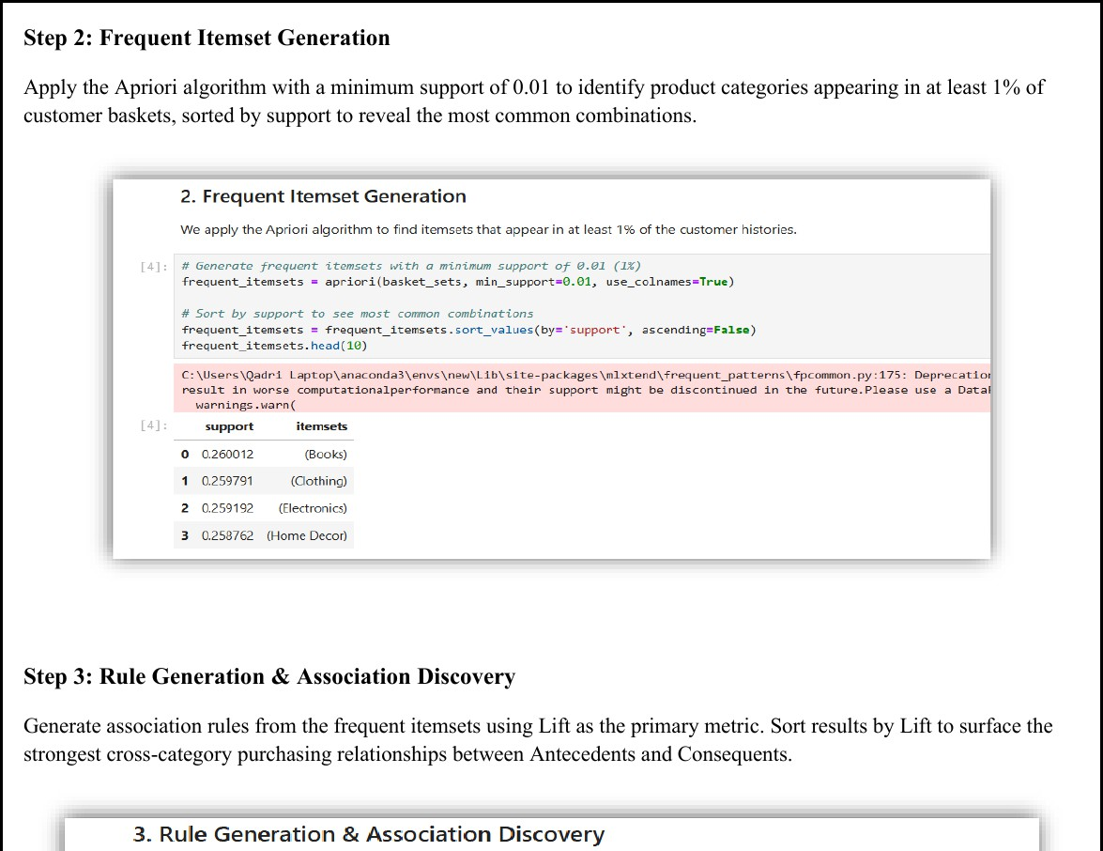

KPI Analysis — Support Threshold Impact
STEP 4
Test four support thresholds (0.005, 0.01, 0.02, 0.05) to observe how threshold selection controls the breadth of discovered associations.

Strategic Conclusion
STEP 5
Identify dominant product combinations, high-lift cross-sell pairs, and the effect of support thresholds on rule discovery.

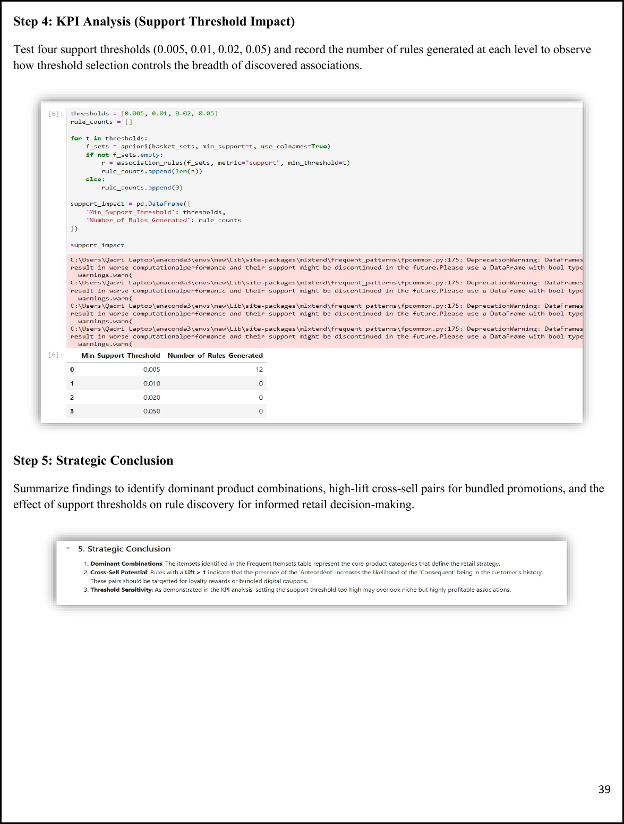

Figure 6.4 — Threshold impact analysis: 12 rules at 0.005, 0 rules at higher thresholds

________________________________________________________
Lab 7: FP-Growth
________________________________________________________

Real-World Scenario: As retail transaction data grows, Apriori becomes slow due to repeated database scanning and large candidate set generation. FP-Growth compresses transaction data into an FP-Tree structure, enabling faster and more scalable frequent pattern mining while maintaining identical accuracy.

Dataset: New Retail Dataset
Attributes: Transaction_ID, Product_Type, Total_Purchases. Records grouped by Transaction_ID form unique baskets. The transaction matrix contains 294,461 transactions across 33 unique product types.

Software: Python — mlxtend (fpgrowth, apriori, association_rules)

Learning Objectives

1  . | Construct an FP-Tree from the transaction matrix for efficient pattern discovery.
2  .  3  .  4  . | Compare execution performance of FP-Growth vs Apriori at the same support threshold.
 | Generate association rules from FP-Growth results using Lift as the evaluation metric.
 | Analyse KPIs: Execution Time, Number of Rules Generated, Efficiency Improvement.

Procedure

Environment Setup
Install mlxtend and import pandas, time, apriori, fpgrowth, and association_rules.
STEP 1

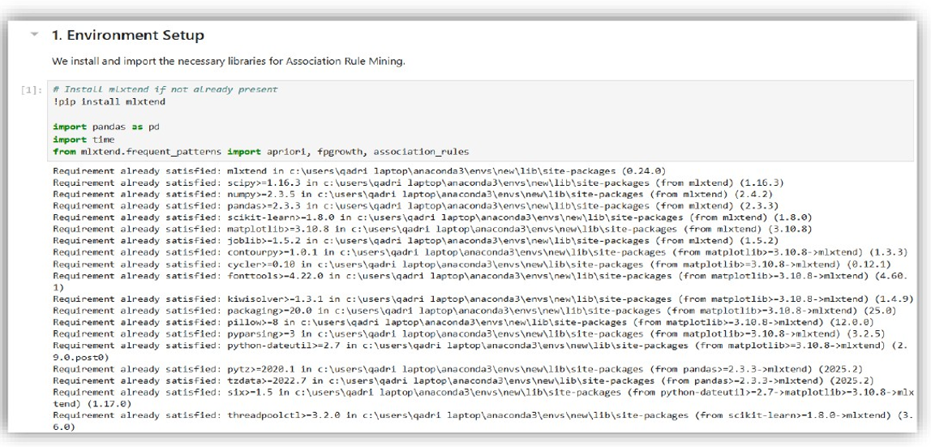

Data Preprocessing
STEP 2
Load dataset, drop missing values in Transaction_ID and Product_Type, pivot into a binary transaction matrix of 294,461 transactions × 33 items.

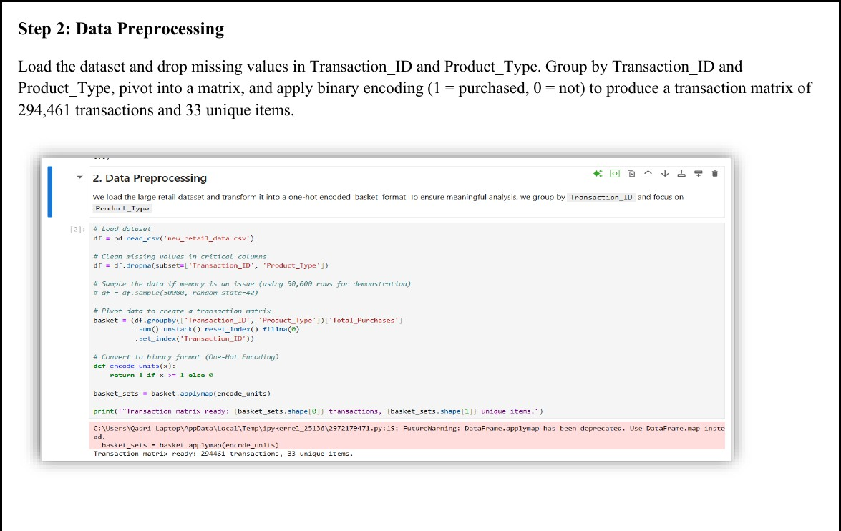

Figure 7.2 — Transaction matrix ready: 294,461 transactions, 33 unique items

Apriori Execution
STEP 3
Run Apriori with minimum support of 0.005 and record execution time as a performance baseline.

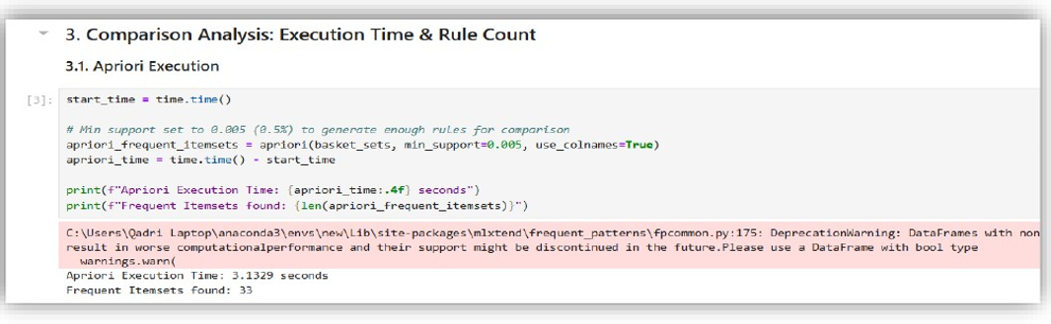

FP-Growth Execution
STEP 4
Run FP-Growth on the same transaction matrix with minimum support of 0.005. FP-Growth builds a compressed FP-Tree and scans the database only twice.

Rule Generation & KPI Summary
STEP 5
Generate association rules from FP-Growth itemsets using Lift as the metric. Build a comparison table.

Final Insights
STEP 6
Both algorithms produce identical rule counts at the same support threshold, confirming FP-Growth's speed advantage does not compromise accuracy.

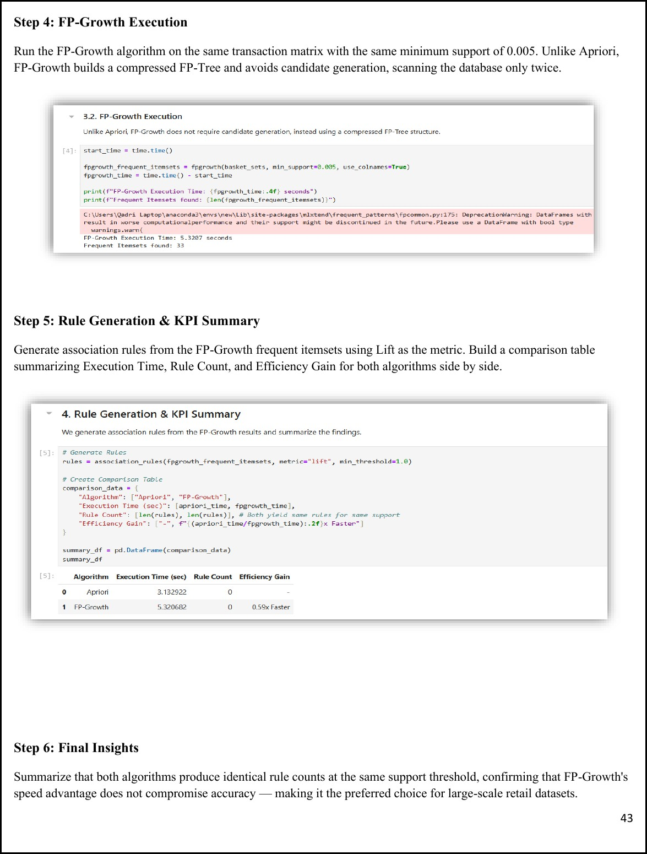

________________________________________________________
Lab 8: Python Basics
________________________________________________________

Real-World Scenario: Data analysts often repeat the same preprocessing steps — loading, cleaning, encoding, and normalising — for different datasets. Without a structured solution, this creates repetitive code and inconsistent outputs. A reusable Python class organises all preprocessing tasks in one place, making data pipelines faster and easier to manage.

Dataset: Student Performance Dataset — 25,000 Records
Attributes: student_id, gender, school_type, attendance_percentage, study_hours, math_score, science_score, english_score, overall_score, final_grade. Each row represents the complete academic profile of one student.

Design Pattern: Object-Oriented Python (StudentDataProcessor class)

Learning Objectives

1  . | Design a reusable Python class for loading, cleaning, and preprocessing data.
2  .  3  .  4  .  5  . | Apply label encoding to categorical columns.
 | Use Min-Max Normalisation for score-related numerical columns.
 | Store metadata and summary results using lists and dictionary structures.
 | Evaluate KPIs: Code Efficiency, Reusability, and Better Workflow Management.

Procedure

Module Definition
Define the StudentDataProcessor class with an init method accepting a file path and initialising the DataFrame and a statistics dictionary. This encapsulates all processing logic within one reusable object.
STEP 1

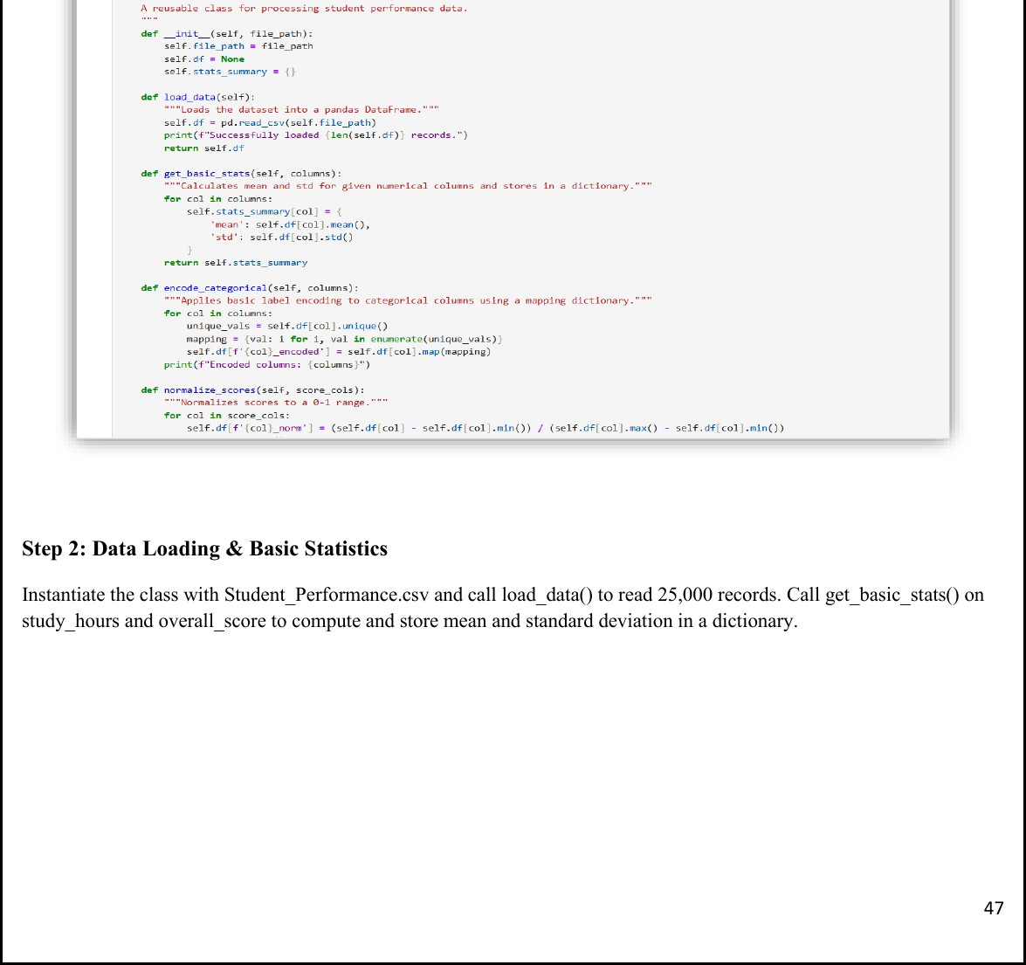

Figure 8.1 — StudentDataProcessor class definition with load, stats, encode, and normalise methods

Data Loading & Basic Statistics
STEP 2
Instantiate the class with Student_Performance.csv, call load_data() to read 25,000 records, then get_basic_stats() to compute mean and std for study_hours and overall_score.

Categorical Encoding
STEP 3
Call encode_categorical() on gender, school_type, and final_grade. Each unique value is mapped to a numeric integer, creating new _encoded columns.

Score Normalisation
STEP 4
Call normalize_scores() on math_score, science_score, and english_score applying Min-Max normalisation (0–1 range), creating new _norm columns.

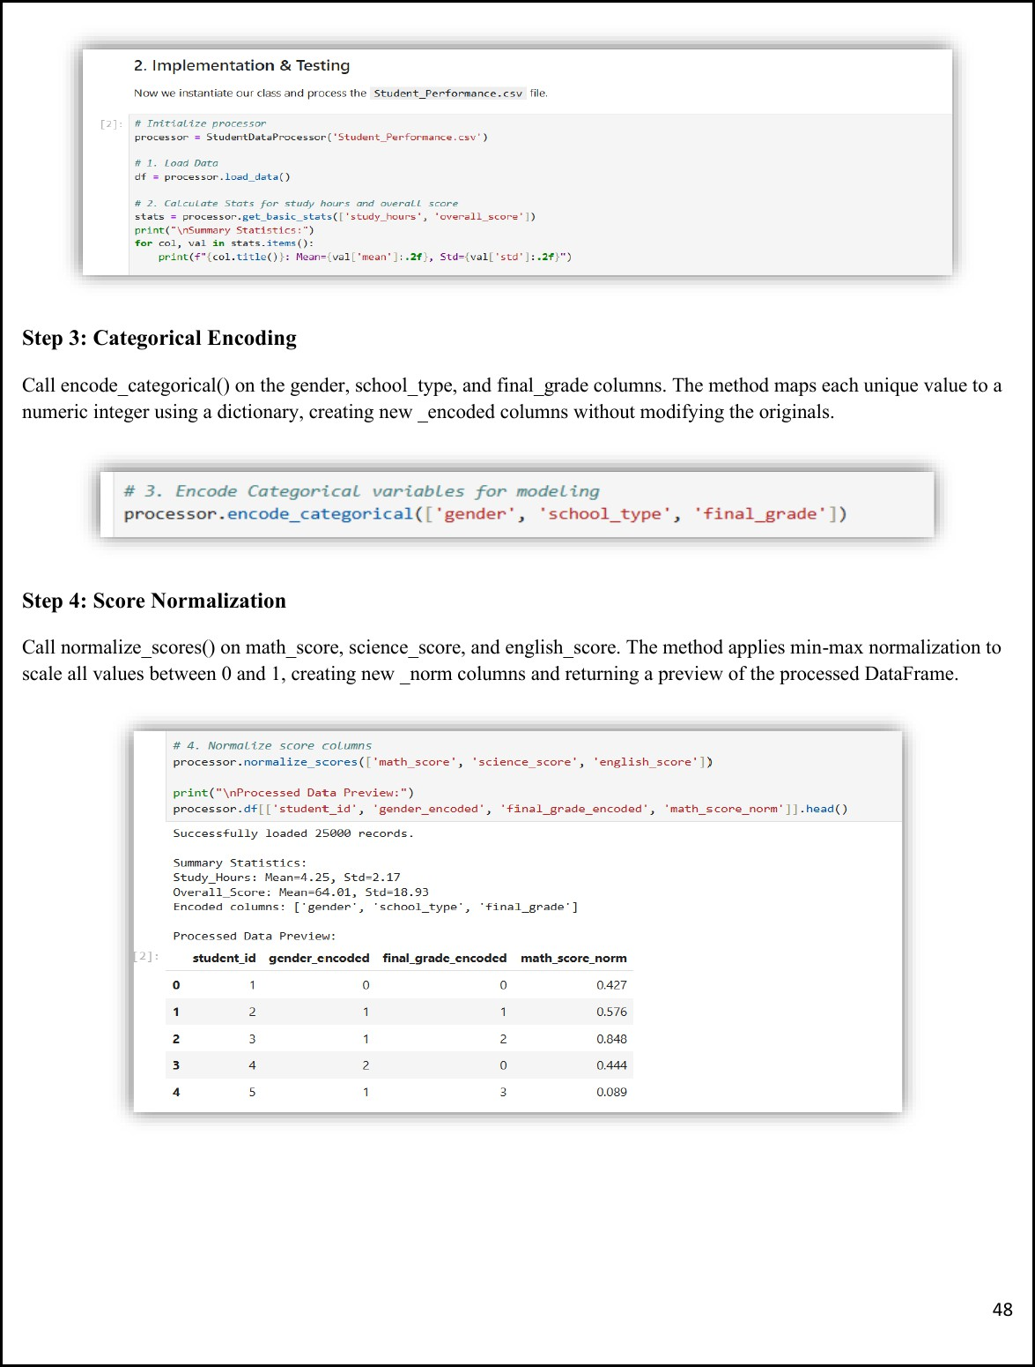

Figure 8.2 — Output: Study Hours Mean=4.25, Overall Score Mean=64.01; encoded and normalised columns preview

Reusability Showcase
STEP 5
Filter the DataFrame for students with attendance > 90% and compute their average overall score — without modifying any class code. Result: 4,957 high-attendance students, average score = 71.22.

Conclusion & KPIs
STEP 6
Summarise module performance across Code Efficiency, Reusability, and Object-Oriented Structure.

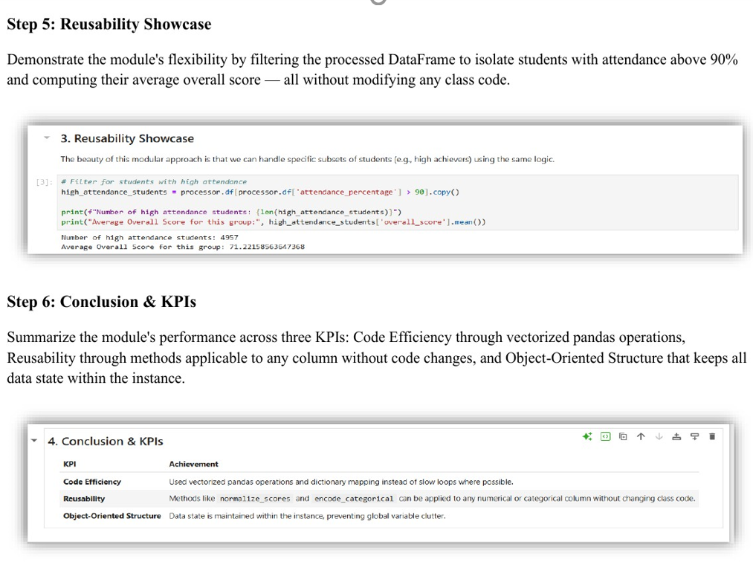

______________________________________________________
Lab 9: Decision Tree (Customer Purchase Prediction)
________________________________________________________

Introduction
A Decision Tree is a supervised machine learning algorithm used for both classification and regression. It works like a flowchart: each internal node represents a decision based on a feature, each branch represents the outcome, and each leaf node represents the final prediction. Decision Trees are easy to understand and visualise because they mimic human decision-making.

Key Concepts
Entropy measures the impurity or randomness in data. Entropy = 0 indicates pure data; higher entropy means more mixed data.

Information Gain = Entropy(Parent) − Weighted Entropy(Children). The feature with the highest Information Gain is selected for splitting.

Gini Index = 1 − Σ(p■²). A lower Gini value indicates better purity.

Components
- Root Node — The topmost node representing the entire dataset.
- Decision Node — A node where data is split based on a condition.
- Branch — Represents the outcome of a decision.
- Leaf Node — The final node containing the class prediction.

Advantages & Limitations

Advantages | Limitations
- Easy to interpret  - No preprocessing needed  - Handles numeric & categorical  - Works for classification & regression | - Can overfit training data  - Sensitive to small data changes  - Lower accuracy vs ensemble methods

Implementation

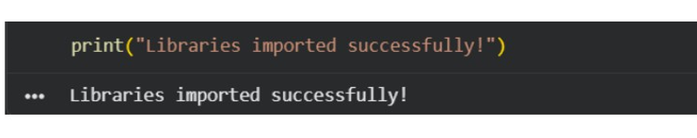

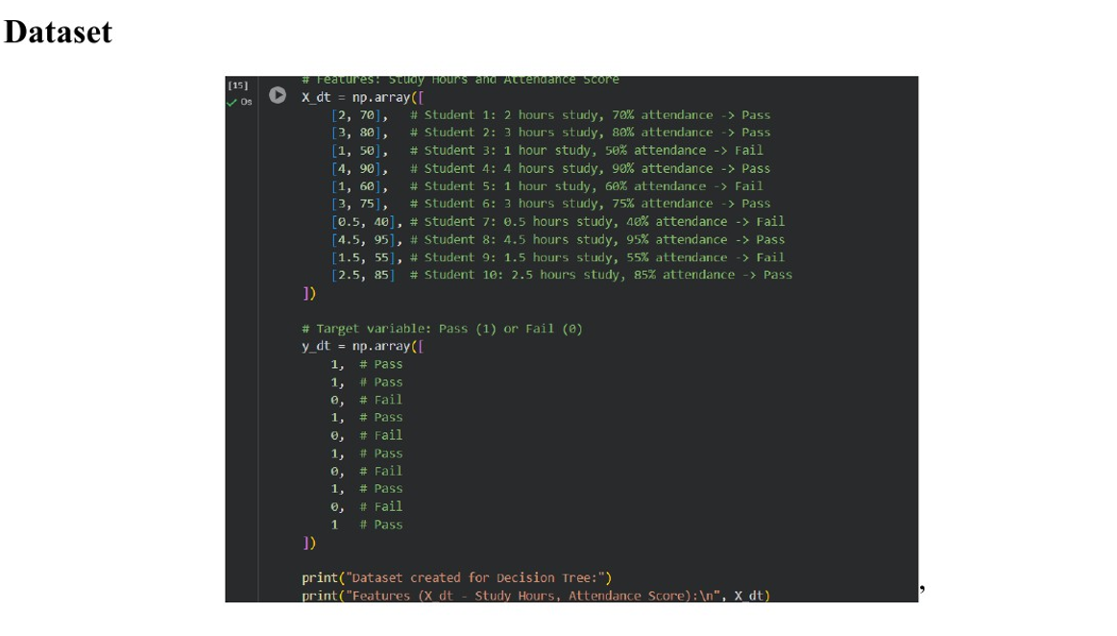

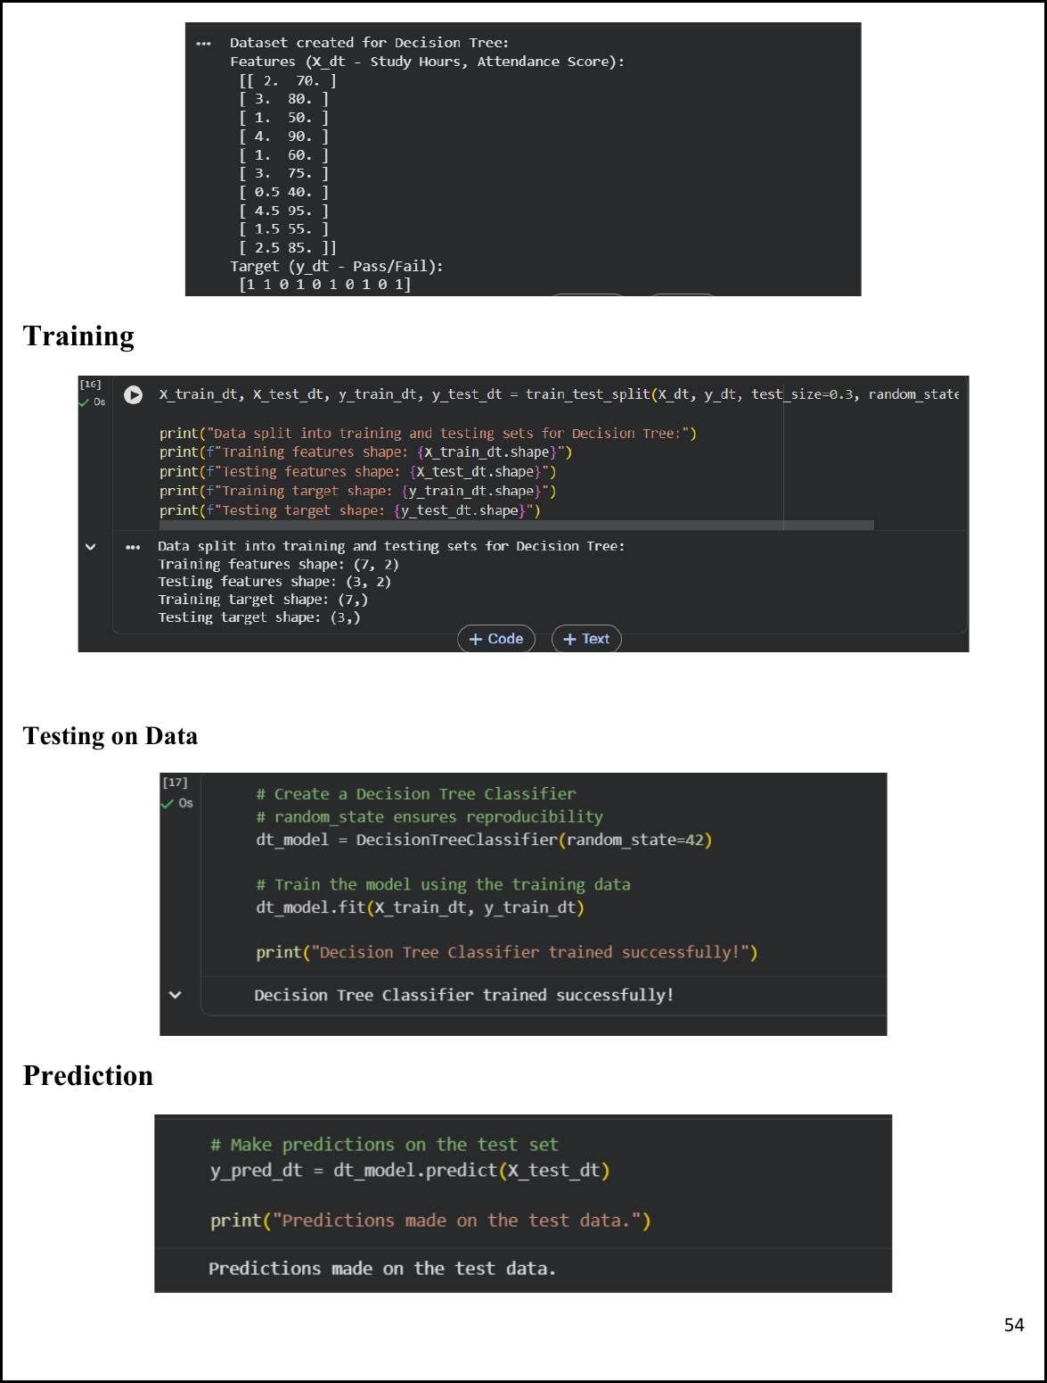

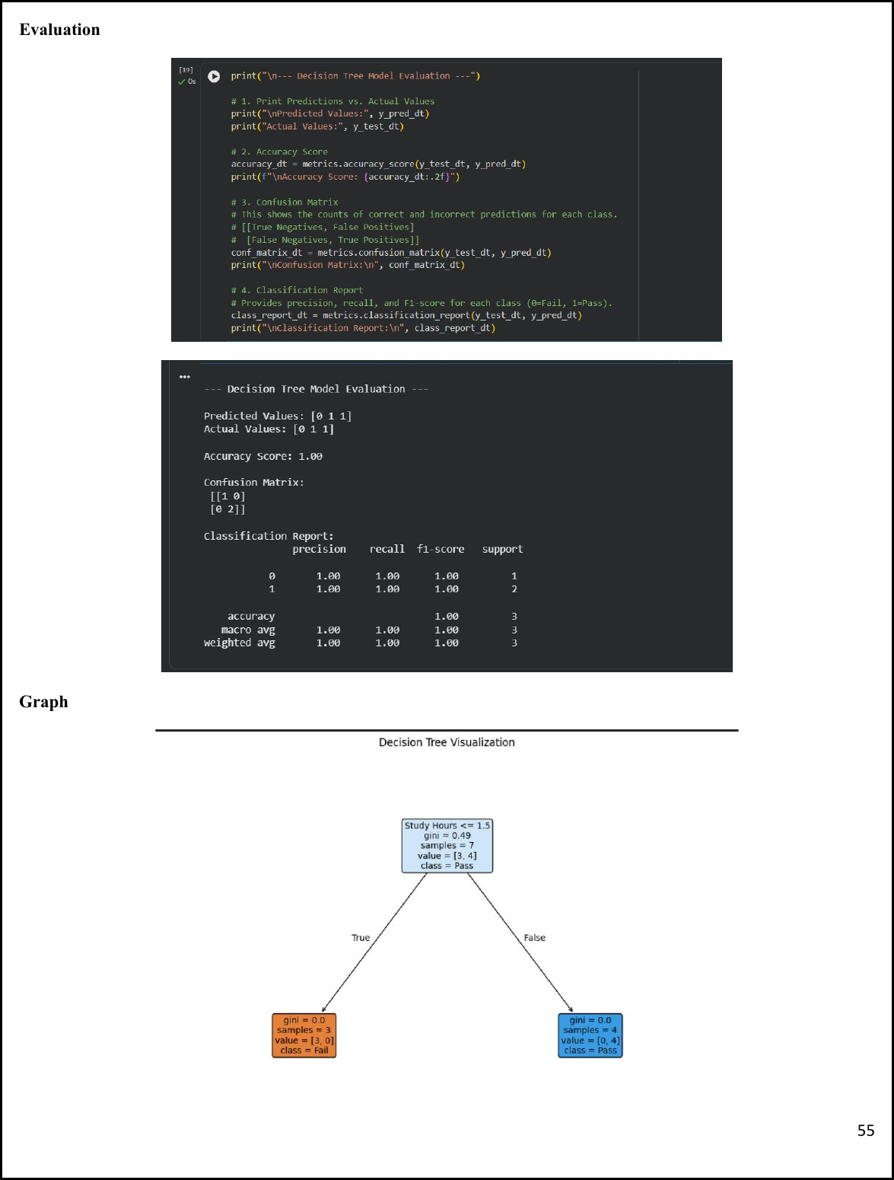

Figure 9.3 — Model evaluation (Accuracy: 1.00) and Decision Tree visualisation

________________________________________________________

Lab 10: Naïve Bayes & KNN (Email Spam Detection)
________________________________________________________

Naïve Bayes Algorithm
Naïve Bayes is a supervised machine learning algorithm based on Bayes' Theorem, primarily used for classification tasks such as spam detection, sentiment analysis, medical diagnosis, and document categorisation. It is called Naïve because it assumes all features are independent of each other.
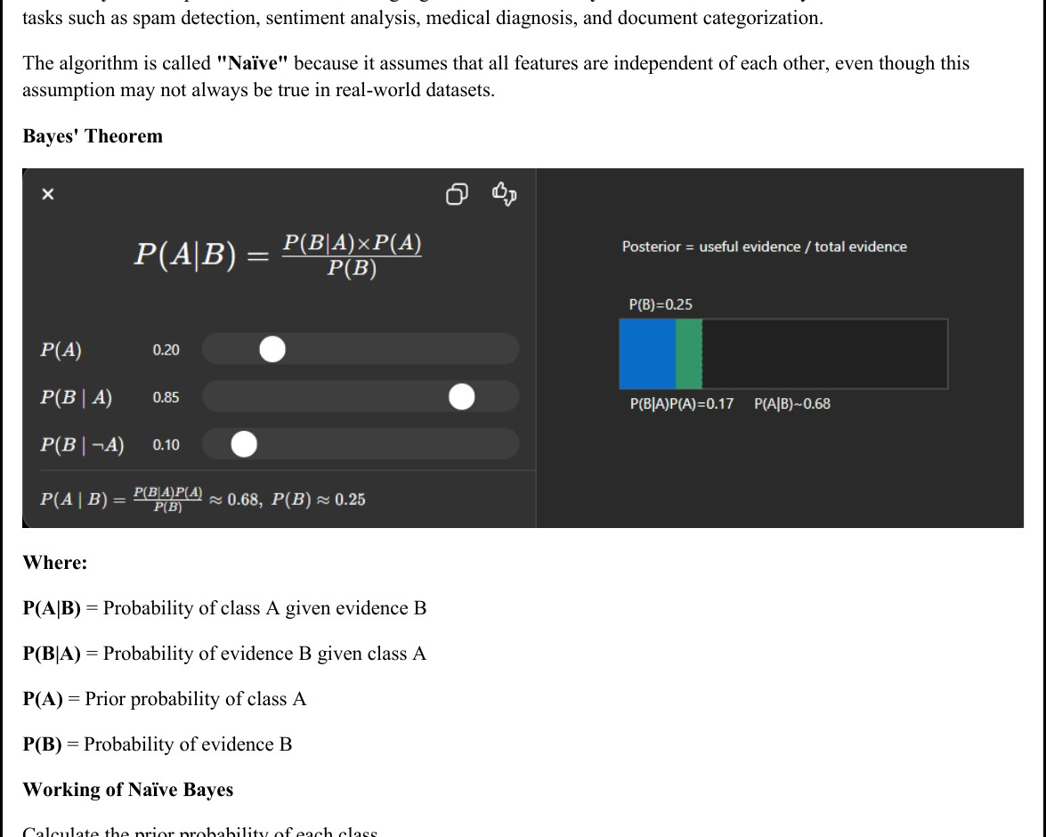
Figure 10.1 — Bayes' Theorem: P(A|B) = P(B|A)×P(A)/P(B)

Types of Naïve Bayes
- Gaussian Naïve Bayes — For continuous numerical data assuming normal distribution.
- Multinomial Naïve Bayes — For text classification using word frequencies.
- Bernoulli Naïve Bayes — For binary (0 or 1) features.

Example: Spam Detection
An email containing words like "Win", "Prize", "Free", "Offer" is scored against the Spam and Not Spam classes. The email is assigned to the class with the higher posterior probability.

Implementation — Naïve Bayes
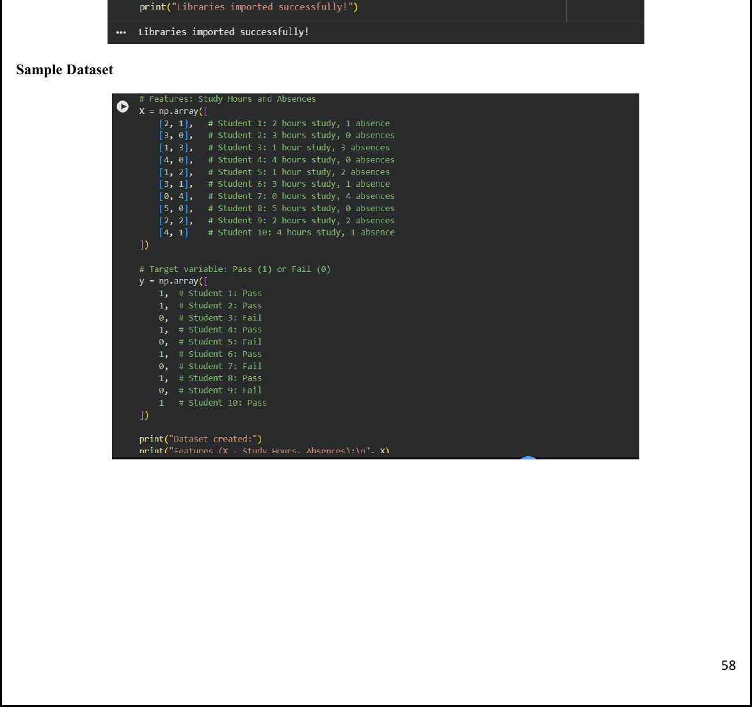

Figure 10.2 — Sample dataset (10 students × 2 features: Study Hours, Absences)

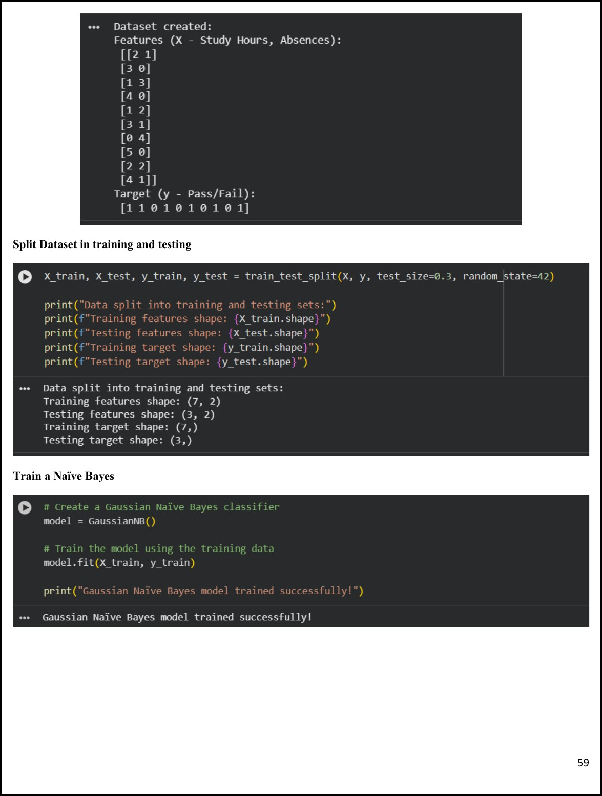

Figure 10.3 — Dataset split, GaussianNB training and predictions

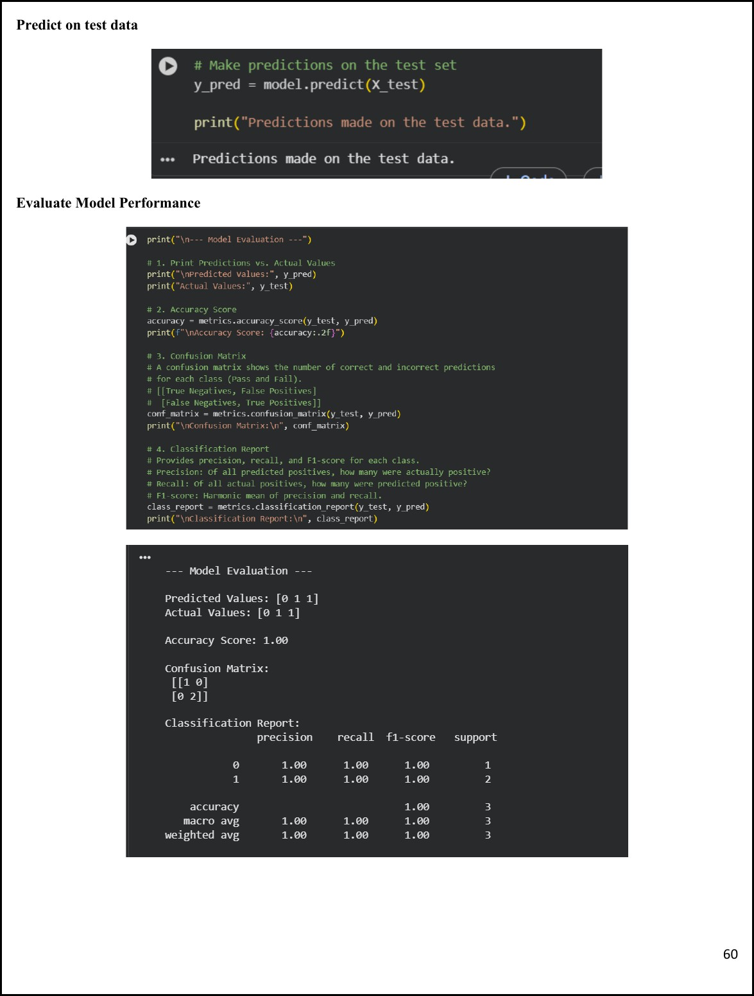

Figure 10.4 — Model evaluation: Accuracy 1.00, Confusion Matrix and Classification Report

________________________________________________________

Lab 11: Support Vector Machine (Credit Card Fraud Detection)
________________________________________________________

Introduction
Support Vector Machine (SVM) is a powerful supervised machine learning algorithm for classification and regression. It classifies data by finding the best decision boundary — called a hyperplane — that separates classes with the maximum possible margin. The data points closest to the boundary are called Support Vectors.

Key Concepts

Hyperplane | Decision boundary separating classes. In 2D, it is a line.
Margin | Distance between the hyperplane and the nearest data points from each class. Larger margins improve generalisation.
Support Vectors | Data points nearest to the hyperplane that determine its position and orientation.
Kernel Trick | Technique for non-linearly separable data. Common kernels: Linear, Polynomial, RBF, Sigmoid.

Implementation

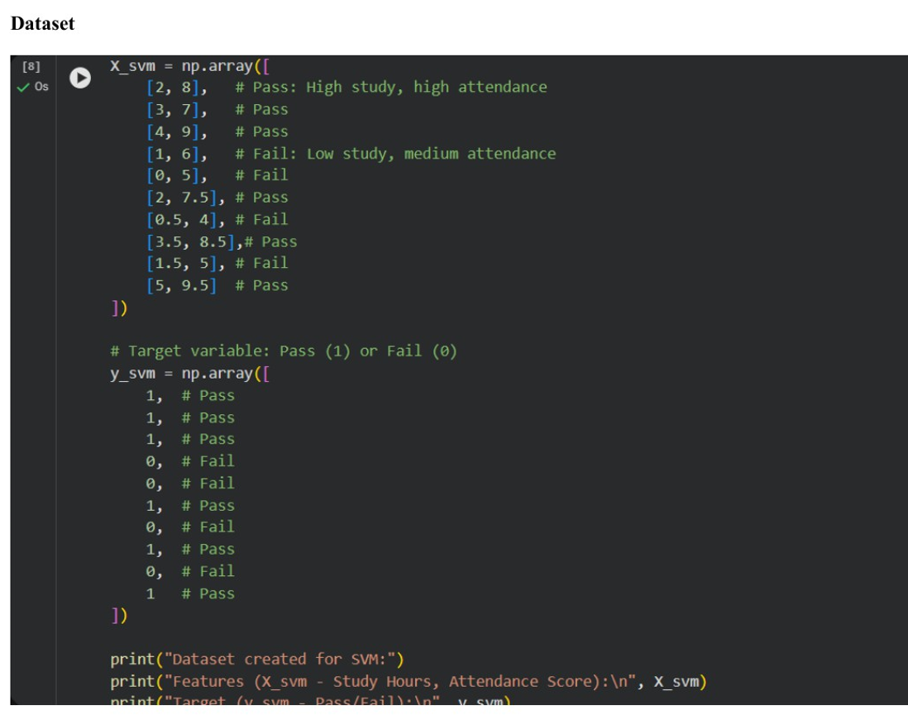

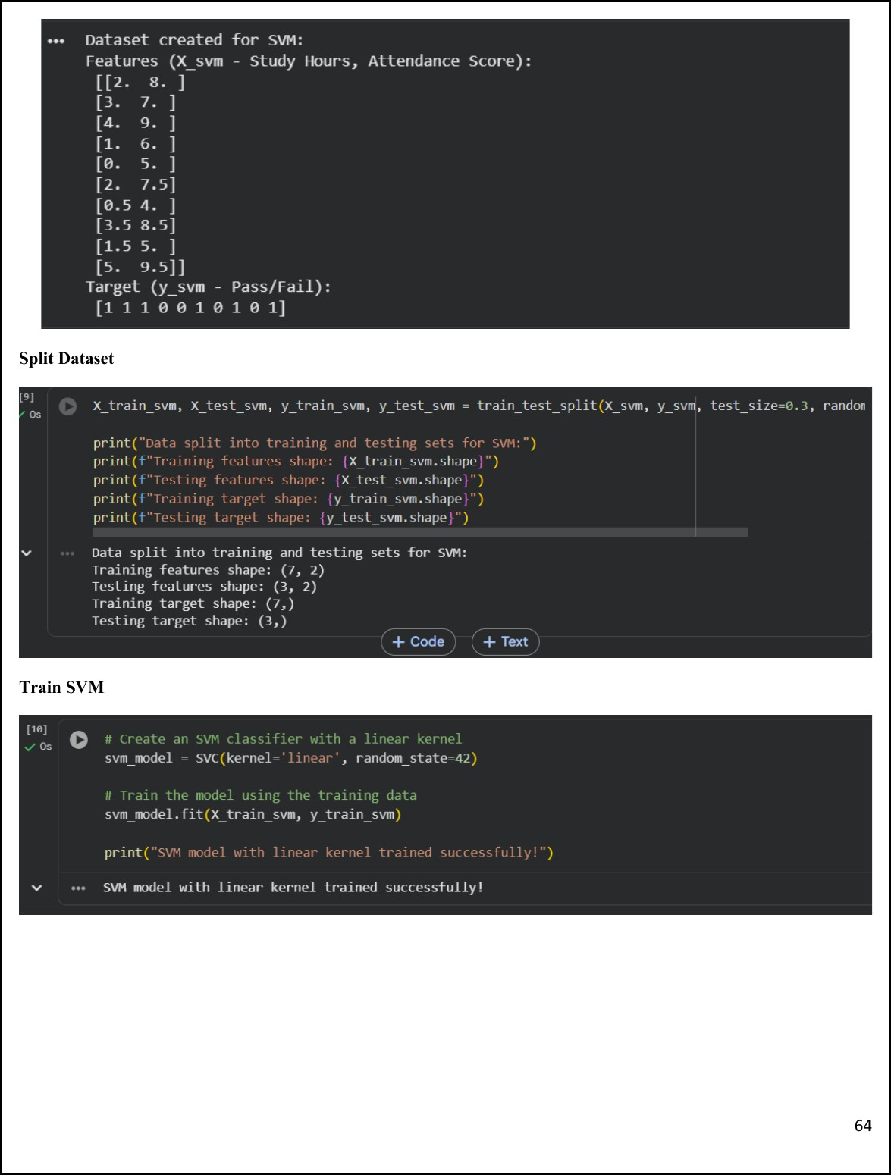

Figure 11.2 — Dataset split (7 train / 3 test) and SVM linear kernel training

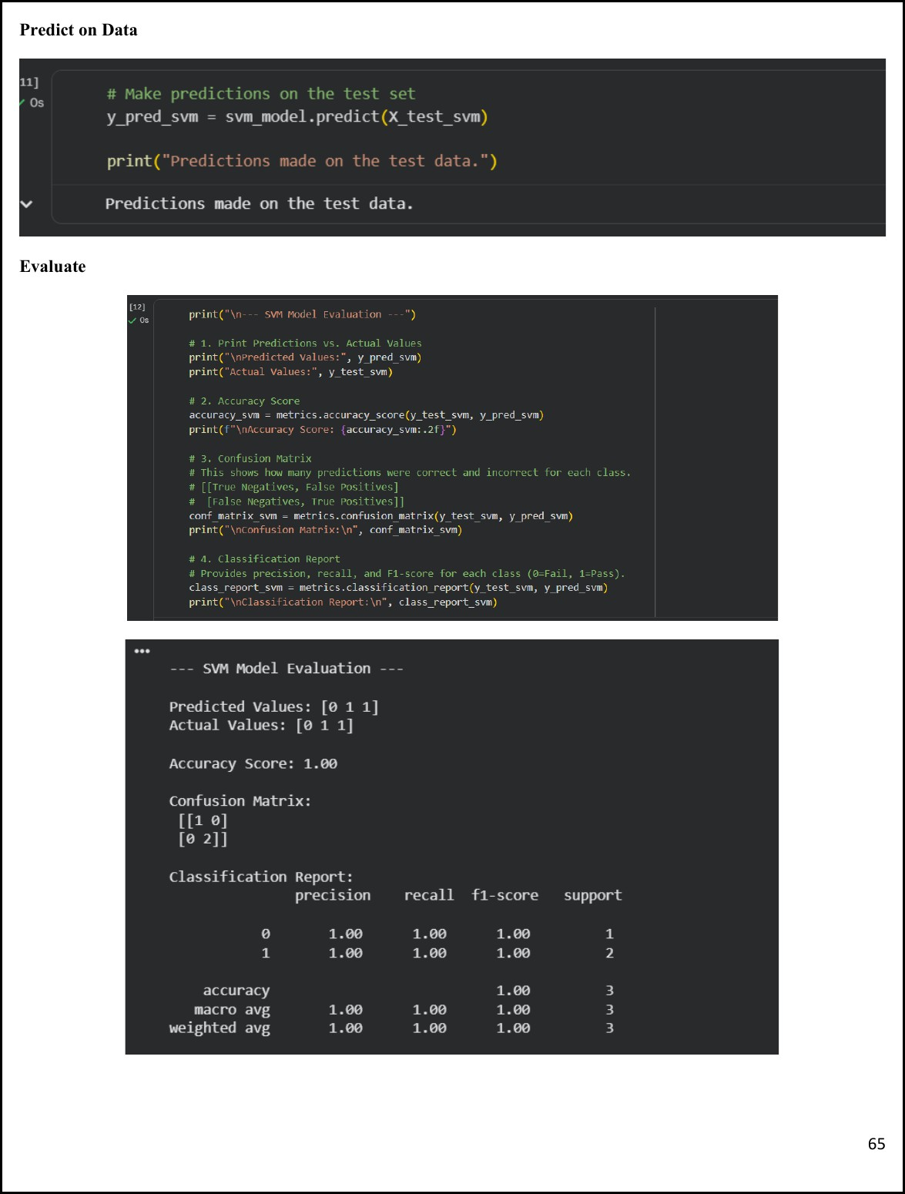

Figure 11.3 — SVM Model Evaluation: Accuracy 1.00, Precision/Recall/F1 all 1.00

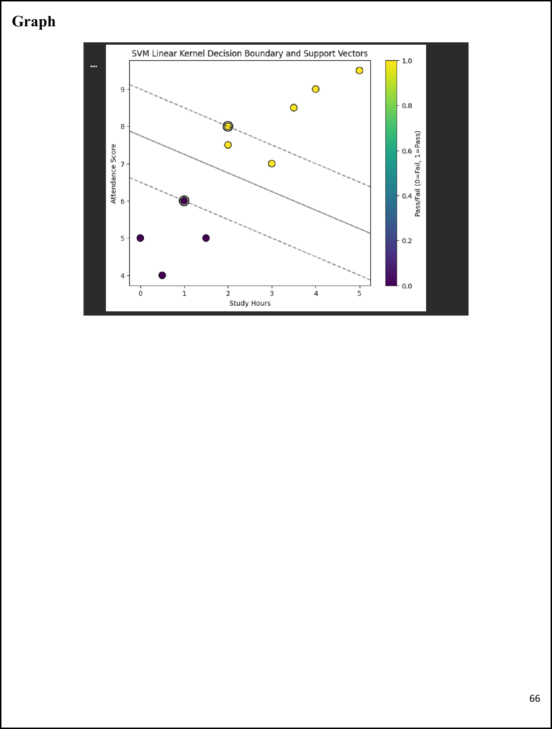

Figure 11.4 — SVM Linear Kernel Decision Boundary and Support Vectors visualisation

________________________________________________________

Lab 12: Clustering (Customer Segmentation)
________________________________________________________

Theory
K-Means is an unsupervised machine learning algorithm that divides data into K clusters. A cluster is a group of data points more similar to each other than to points in other clusters. The algorithm minimises the Within-Cluster Sum of Squares (WCSS) by repeatedly assigning data points to the nearest centroid and updating centroid positions until convergence.

Algorithm Steps
- Select the number of clusters K.
- Initialise K centroids randomly.
- Assign each data point to the nearest centroid.
- Recalculate centroids as the mean of assigned points.
- Repeat assignment and update steps until convergence.

Applications: customer segmentation, image compression, document grouping, market analysis, recommendation systems, anomaly detection.

Implementation

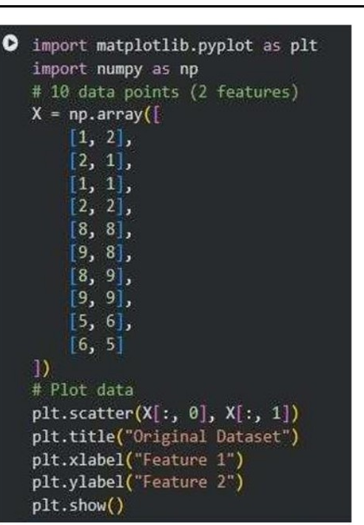

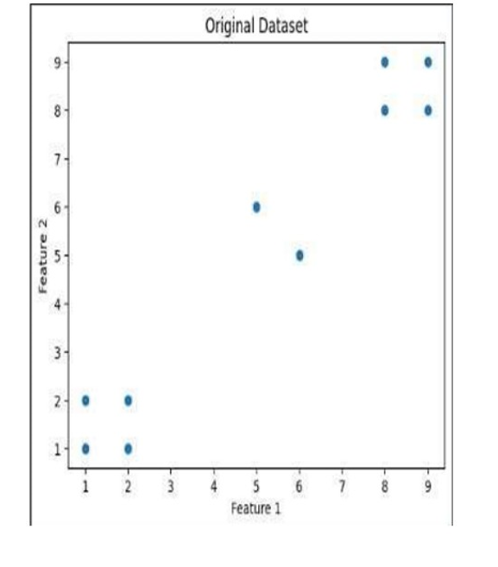

Figure 12.1 — 10-point dataset (2 features) and original scatter plot

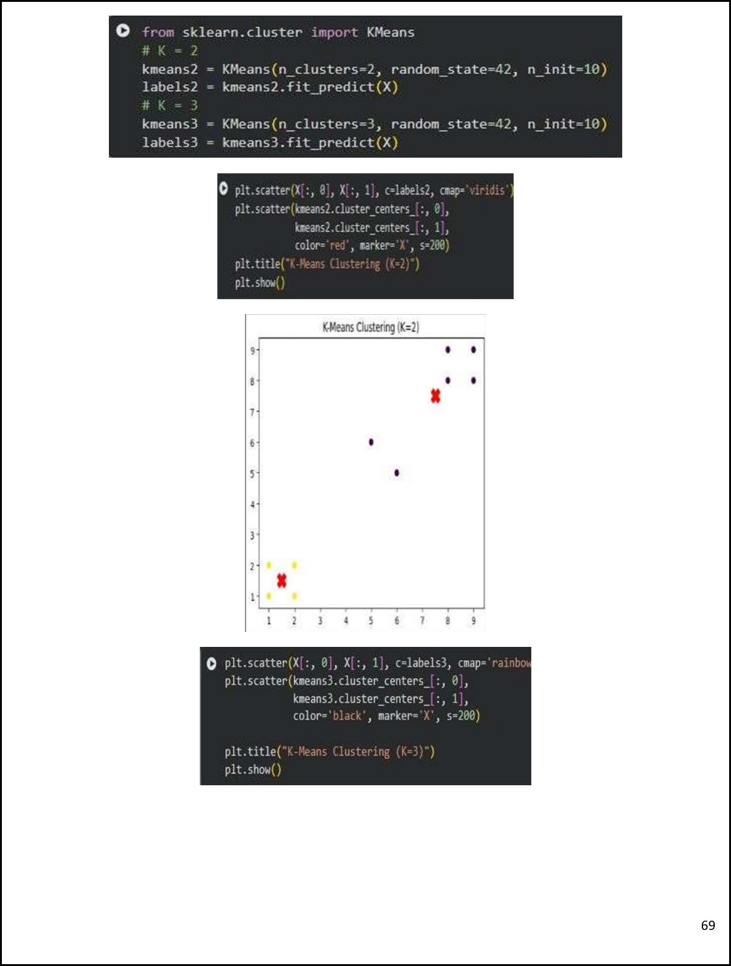

Figure 12.2 — K-Means clustering with K=2 and K=3; centroids marked with X

K-Nearest Neighbours (KNN)

KNN is a supervised classification algorithm that assigns a new data point to the class most common among its K nearest neighbours. It is non-parametric and instance-based — no model is trained; predictions are made directly from stored training examples.

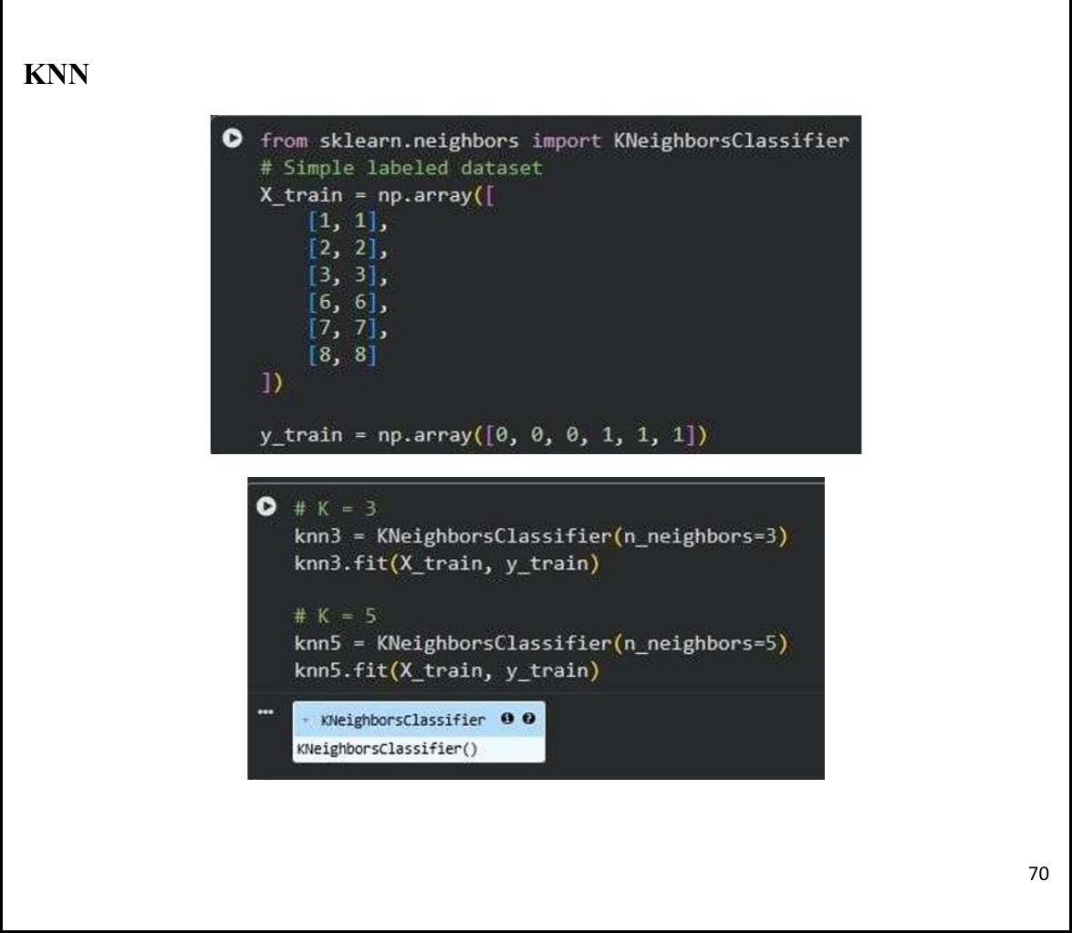

Figure 12.3 — KNN with K=3 and K=5 trained on 6-point dataset; both predict class [0] for point [4,4]

________________________________________________________

Lab 13: Outlier Detection (Abnormal Banking Transactions)
________________________________________________________

Detection Methods

Outliers are data points far from most other points. A point is considered an outlier if it has very few nearby neighbours within a distance R.  Idea: "Far from others = Outlier" | Isolation Forest is an anomaly detection algorithm. It works by randomly splitting data. Outliers get isolated quickly (short path length).  Idea: "Easy to isolate = Outlier"

Common Datasets for Outlier Detection
- Iris dataset — classic benchmark for anomaly detection algorithms.
- Credit Card Fraud dataset — detecting fraudulent transactions.
- Wine Quality dataset — identifying atypical batches.
- Breast Cancer dataset — flagging unusual diagnostic patterns.

Implementation

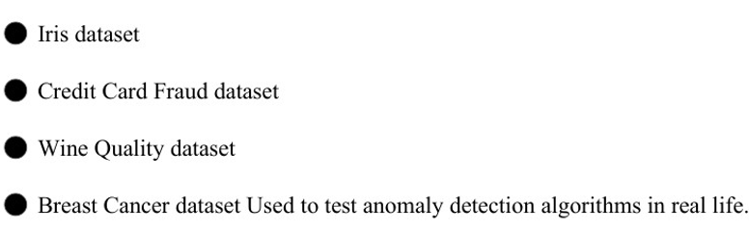

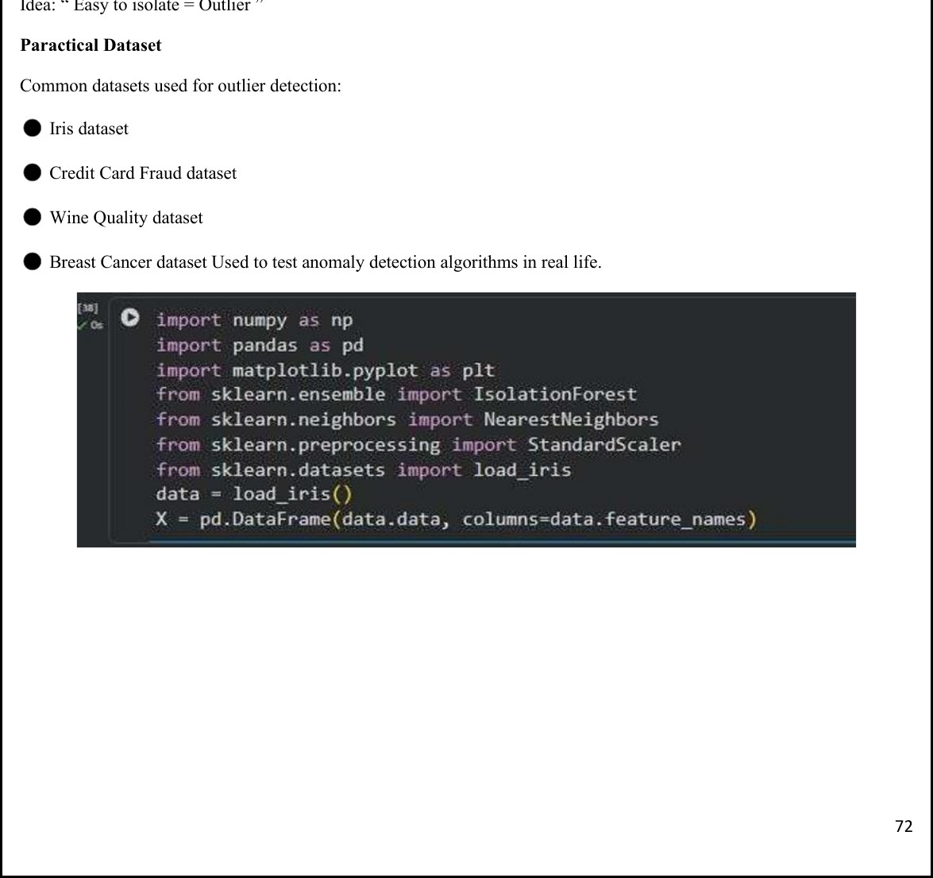

Figure 13.1 — Iris dataset loaded; IsolationForest and NearestNeighbors imported

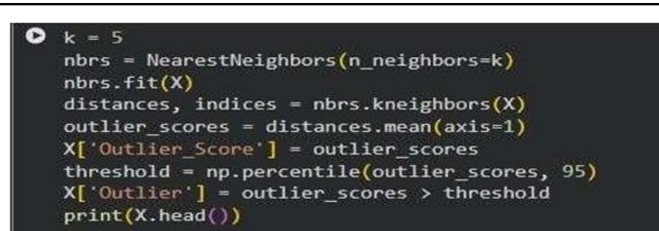

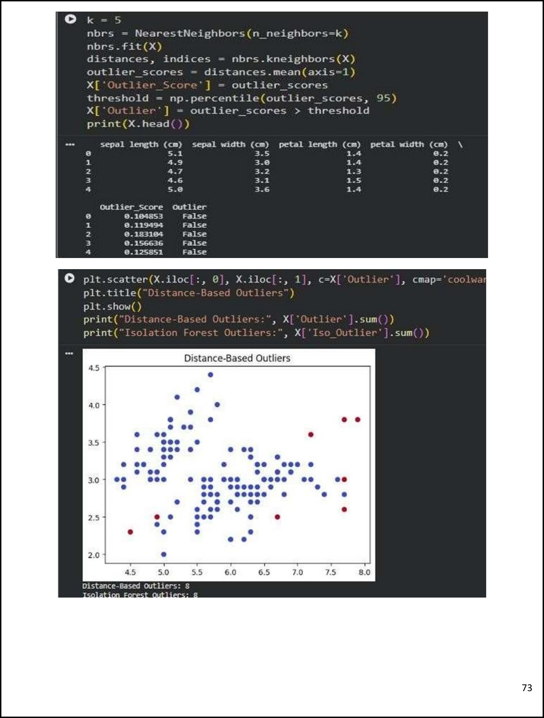

Figure 13.2 — Distance-based outlier scores (k=5 neighbours) and scatter plot; 8 outliers detected by both methods

________________________________________________________

Lab 14: Scraping & Sentiment Analysis (Product Reviews)
________________________________________________________

Theory
Sentiment Analysis is an NLP technique used to determine the emotional tone of text, automatically classifying content as Positive, Negative, or Neutral. Organisations use it to understand customer opinions from reviews, social media posts, surveys, and feedback.
VADER Sentiment Analyzer (Valence Aware Dictionary and Sentiment Reasoner) is a lexicon and rule-based tool designed for social media content and short texts. It produces four scores — Positive,
Negative, Neutral, and Compound. The Compound score summarises overall sentiment on a scale from
−1 to +1. Classification: Compound ≥ 0.05 → Positive; ≤ −0.05 → Negative; otherwise Neutral.

Applications
- Product review analysis and brand reputation management.
- Social media monitoring and public opinion tracking.
- Customer feedback evaluation and market research.
- Political analysis and business intelligence.

Examples

Review Text | Sentiment
"This mobile phone is excellent" | - Positive
"The service was very bad" | ✗ Negative
"The product is average" | - Neutral
"I am happy with the purchase" | - Positive
"The delivery was delayed and disappointing" | ✗ Negative

Implementation

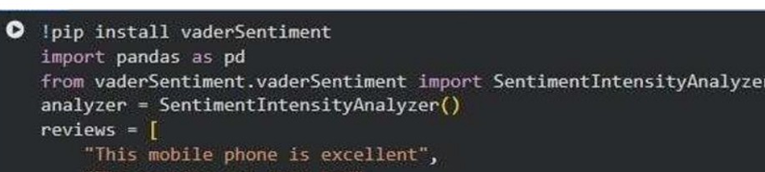

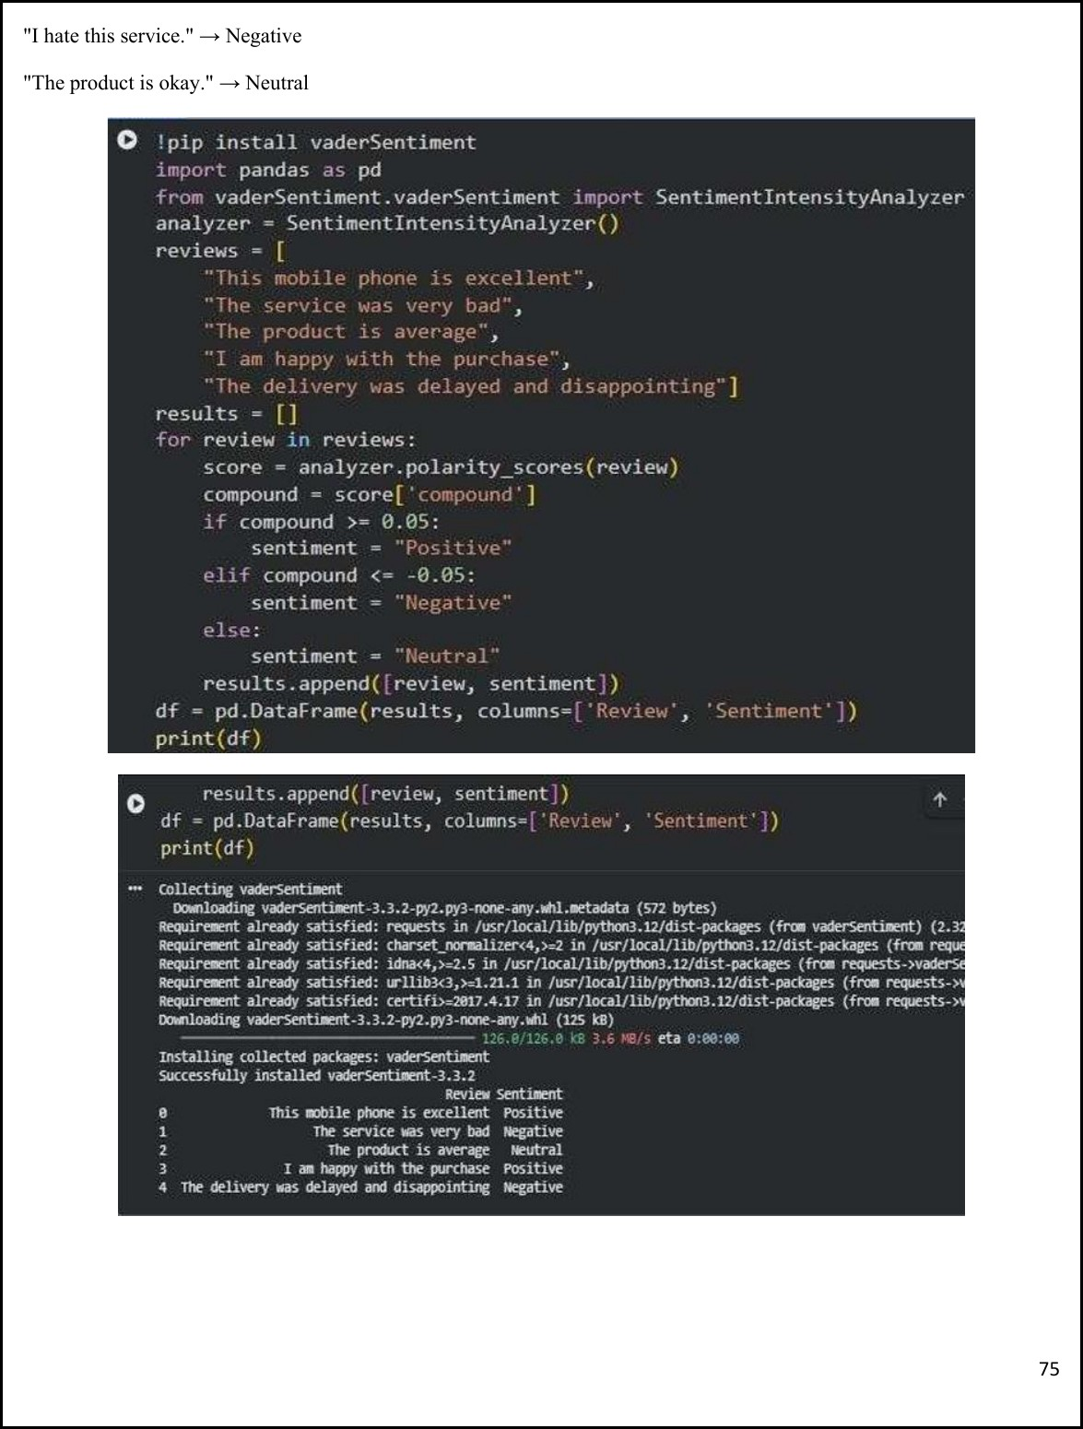

Figure 14.1 — VADER Sentiment Analyzer applied to 5 product reviews with classification output

________________________________________________________

Lab 15: Final Capstone (End-to-End Business Solution)
________________________________________________________

Theoretical Foundation

Objective: Develop a complete data mining solution integrating data preprocessing, sentiment analysis, classification, clustering, and recommendation techniques to extract meaningful insights from customer review data and support business decision-making.

Real-World Scenario
E-commerce companies receive thousands of customer reviews daily. Manual analysis is impractical. Businesses need automated systems that determine customer sentiment, identify customer segments, and recommend products based on purchasing behaviour. This capstone combines multiple data mining techniques into one intelligent analytics system.

Dataset Description
~10,000 customer review records. Attributes: Review ID, Customer ID, Product Name, Product Category, Review Text, Rating, Purchase Date, Customer Age, Customer Location. Combines textual and numerical data across multiple product categories.

Project Workflow

Data Collection
Load the customer review dataset. Import and inspect records. Verify data types.
STEP 1

Data Cleaning
STEP 2
Remove duplicates, handle missing values, standardise text. KPIs: Data Quality Score, Missing Value Reduction %.

Sentiment Analysis
STEP 3
Apply VADER Sentiment Analyzer. Output classes: Positive, Negative, Neutral. KPIs: % Positive Reviews, % Negative Reviews, Average Compound Score.

Classification
STEP 4
Train Decision Tree, Naïve Bayes, and SVM models. Evaluation Metrics: Accuracy, Precision, Recall, F1-Score.

Customer Clustering
STEP 5
Apply K-Means Clustering to group customers by Purchase Frequency, Ratings, and Spending Behaviour. KPIs: Number of Clusters, Cluster Characteristics.

Recommendation
STEP 6
Use association rule mining (Apriori / FP-Growth) with Support, Confidence, and Lift to recommend frequently co-purchased products.

Visualisation
STEP 7
Create charts for Sentiment Distribution, Customer Clusters, Top Products, and Association Rules.

Sample Results

Metric | Result
Positive Reviews | 72%
Neutral Reviews | 18%
Negative Reviews | 10%
Customer Segments | 4 distinct clusters identified
Top Recommended Pair | Mobile Cover → Screen Protector
Highest Engagement Category | Electronics

Business Insights
- Customers are generally satisfied with products (72% positive reviews).
- Electronics category generates the highest customer engagement.
- High-spending customers belong primarily to Cluster 2.
- Product bundles can significantly increase sales through cross-selling strategies.

— END OF LAB MANUAL —

